
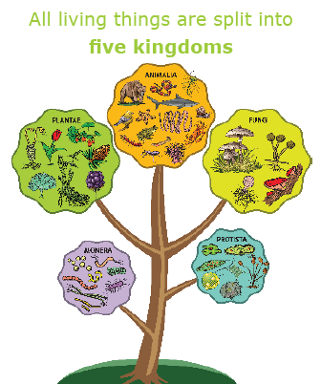
Grouping Living Things
Animals can be put into one of two groups | Vertebrates or Invertebrates
Vertebrates: Animals with a backbone
There are 5 ways Vertebrates can be grouped | • Fish  • Amphibians  • Reptiles  • Birds  • Mammals
How to spot a Fish | • Breathes with gills/lays eggs in water/ has fins and scales/its body temperature changes
How to spot an Amphibian | • Born with gills then develops lungs/ lays eggs in water/damp skin/body temperature changes
How to spot a Reptile | • Breathes with lungs/lays eggs on land/ dry scaly skin/body temperature changes
How to spot a Bird | • Breathes with lungs/lays eggs with hard shells/has feathers/steady body temperature
How to spot a Mammal | • Breathes with lungs/babies are born live/body hair or fur/steady body temperature/feeds babies milk
Invertebrates: Animals without a backbone
There are 3 ways Invertebrates can be grouped | • Insects  •Arachnids  • Molluscs
How to spot an Insect | • 3 body sections/6 legs
How to spot an Arachnid | • 2 body sections/8 legs
How to spot a Mollusc | • Slimy foot/Often have a shell

Deciding which animal or plant is which
Key Features to distinguish between animals | • Invertebrate or Vertebrate  • Mammal/Reptile/Fish/Amphibian/Bird  • Colour  • Length  • Number of legs  • Number of body segments  • Distinguishing features  • Habitat
Key Features to distinguish between plants | • Flowering or Non-Flowering  • Grass/cereal/garden shrub/deciduous/ algae/coniferous/fern  • Colour  • Height  • Number of flowers  • Fruit bearing or not  • Distinguishing features  • Usual location
Carl Linnaeus
Born in Sweden on 23rd May 1707
A leading light in the field of Taxonomy
Famous for developing the first system to classify animals effectively.
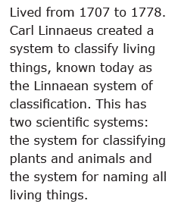

Science
Topic: Living Things and Their Habitats Yr grp: 6
Key Vocabulary
adaptation | a change in structure or function that improves the chance of survival for an animal or plant within a given environment
body temperature | how hot or cold the inside of an animals body is
carnivore | an animal that eats meat
classification | grouping something using its features
criteria | a factor on which something is judged
deciduous | trees that lose leaves in the autumn every year
distinguish | recognise a difference
environment | all the circumstances, people, things, and events around them that influence their life
evergreen (coniferous) | a tree or bush which has green leaves all the year round
food chain | a series of living things which are linked to each other because each thing feeds on the one next to it in the series
habitat | the natural environment in which an animal or plant normally lives or grows
herbivore | an animal that only eats plants
omnivore | person or animal eats all kinds of food, including both meat and plants
taxonomy | part of science focused on classification


