 | Autumn A | Autumn B | Spring A |  | Spring B |  | Summer A |  | Summer B
EYFS | Our School  PLACE | Changes within Living Memory: Toys  CONTINUITY AND CHANGE | China  PLACE  Chinese New Year |  | Space  Significant people places and events  SIGNIFICANCE |  | Changes within Living Memory: Games CONTINUITY AND CHANGE  David Attenborough Films/camera |  | My House and My Road  LOCATION AND PLACE  Maps and Directions
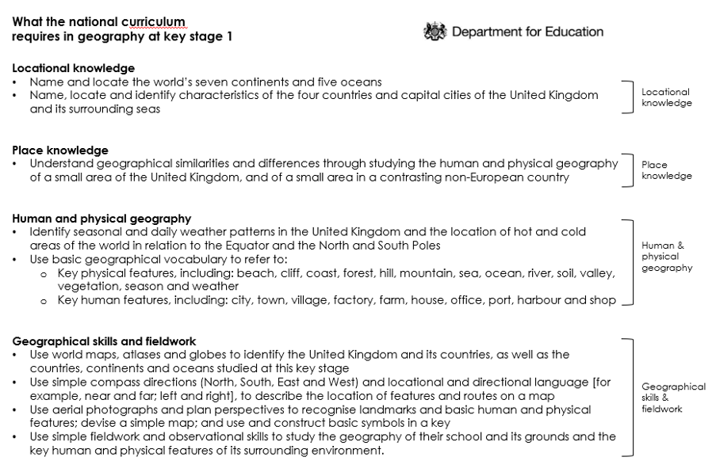
Revisit:
Our school – place
China (Place)
My House and Road (location and place)
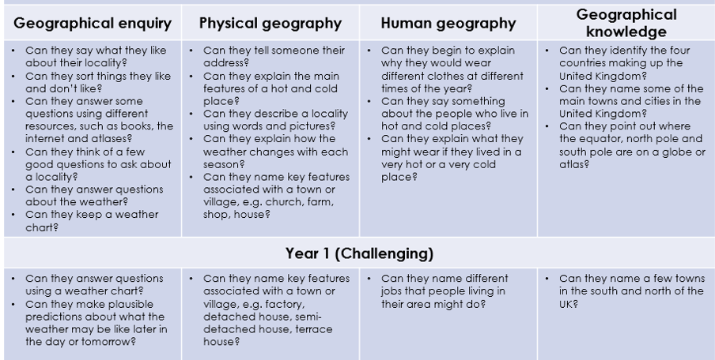
Y1 | Little Blue Planet LOCATION AND PLACE | Changes within Living Memory: Communication  CONTINUITY AND CHANGE | Local Study: Newburn  LOCATION AND PLACE  PLANNING AND DECISION MAKING |  | Grace Darling  Significant people places and events locally  SIGNIFICANCE |  | Animals Around the World  CHANGE  LOCATION AND PLACE |  | George Stephenson  Significant people places and events locally  SIGNIFICANCE
Use basic geographical vocabulary to refer to:  Key physical features, including: beach, cliff, coast, forest, hill, mountain, sea, ocean, river, soil, valley, vegetation, season and weather.  Key human features, including: city, town, village, factory, farm, house, office, port, harbour and shop. (Human and Physical) | Name and locate world’s seven continents and 5 oceans (locational)  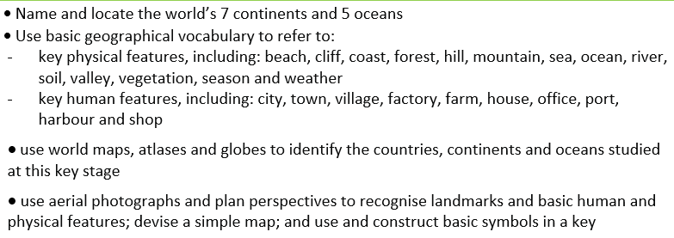  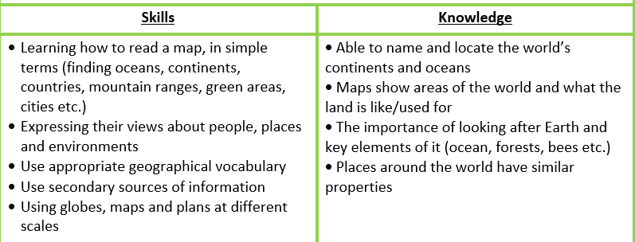 |  | Understand geographical similarities and differences through studying the human and physical geography of a small area of the United Kingdom and of a small area in a contrasting non-European country. (Place)  Use world maps, atlases and globes to identify the UK and its countries, as well as the countries, continents and oceans studied at this key stage.  Use simple compass directions (N, S, E and W) and locational and directional language, to describe the location of features and routes on a map.  Use aerial photographs and plan perspectives to recognise landmarks and basic human and physical features; devise a simple map: and use and construct basic symbols in a key.  Use simple fieldwork and observational skills to study the geography of their school and its grounds and the key human and physical features of its surrounding environment. (Geographical skills and fieldwork).  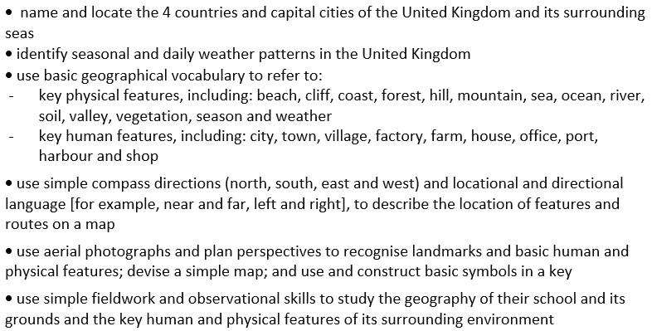  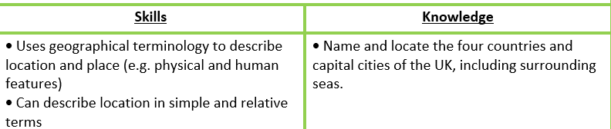  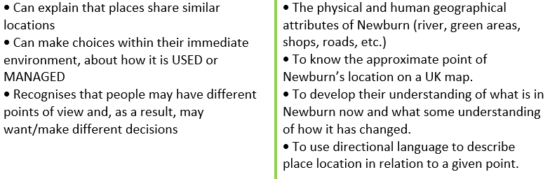 |  |  |  | 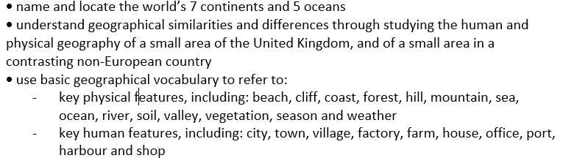  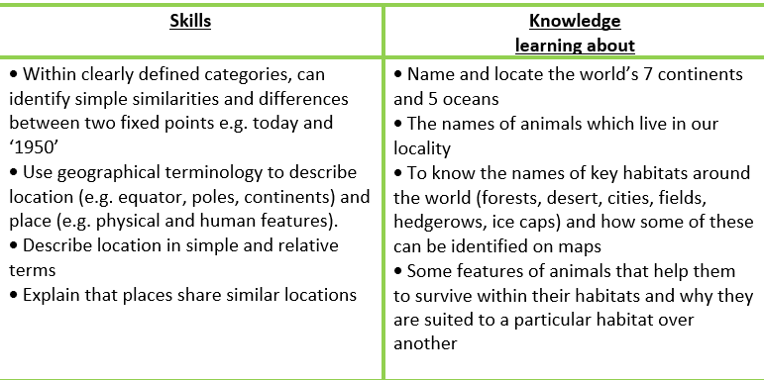 |  | Use world maps, atlases and globes to identify the UK and its countries, as well as the countries, continents and oceans studied at this key stage.  Use simple compass directions (N, S, E and W) and locational and directional language, to describe the location of features and routes on a map.  Use aerial photographs and plan perspectives to recognise landmarks and basic human and physical features; devise a simple map: and use and construct basic symbols in a key.  Use simple fieldwork and observational skills to study the geography of their school and its grounds and the key human and physical features of its surrounding environment. (Geographical skills and fieldwork).
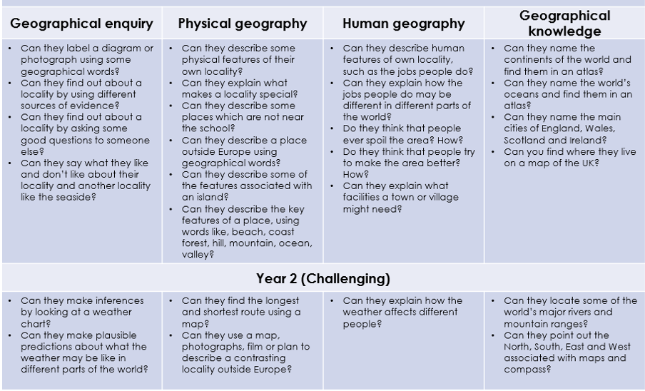
Revisit:
7 continents and 5 oceans.
Local Study Newburn (Place)

Y2 | Great Fire of London and Newcastle  CAUSE AND CONSEQUENCE  HISTORICAL EVIDENCE | Polar Regions LOCATION AND PLACE  CAUSE AND CONSEQUENCE  CHANGE |  | Explorers Significant people places and events internationally  SIGNIFICANCE | Australia  LOCATION AND PLACE  PLANNING AND DECISION MAKING |  | Australia | Civil Rights | Civil Rights  Significant people places and events internationally  SIGNIFICANCE
Use basic geographical vocabulary to refer to:  Key physical features, including: beach, cliff, coast, forest, hill, mountain, sea, ocean, river, soil, valley, vegetation, season and weather.  Key human features, including: city, town, village, factory, farm, house, office, port, harbour and shop. (Human and Physical) | Use world maps, atlases and globes to identify the UK and its countries, as well as the countries, continents and oceans studied at this key stage.  Use simple compass directions (N, S, E and W) and locational and directional language, to describe the location of features and routes on a map.  Use aerial photographs and plan perspectives to recognise landmarks and basic human and physical features; devise a simple map: and use and construct basic symbols in a key.  Use simple fieldwork and observational skills to study the geography of their school and its grounds and the key human and physical features of its surrounding environment. (Geographical skills and fieldwork). | Name and locate world’s seven continents and 5 oceans (locational) Revisit.  Identify seasonal and daily weather patterns in the UK and the location of hot and cold areas of the world in relation to the Equator and the North and South Poles.  (Human and Physical) |  | Maps, atlases and globes to identify journeys. Compass directions and locational and directional language. Aerial photographs and plan perspectives. Oceans and surrounding countries. (Scott, Shackleton, Tom Crean, Felicity Aston, Matthew Henson, Roald Amundsen, Ann Bancroft). Identify the location of hot and cold areas of the world in relation to the Equator and the North and South Poles. Captain Cook (UK, landmarks, physical and human features of area) Amelia Earhart, Neil Armstrong etc. | Understand geographical similarities and differences through studying the human and physical geography of a small area of the United Kingdom and of a small area in a contrasting non-European country. (Place)  Use simple compass directions (N, S, E and W) and locational and directional language, to describe the location of features and routes on a map. (Geog skills + Fieldwork) |  | Use aerial photographs and plan perspectives to recognise landmarks and basic human and physical features; devise a simple map: and use and construct basic symbols in a key.  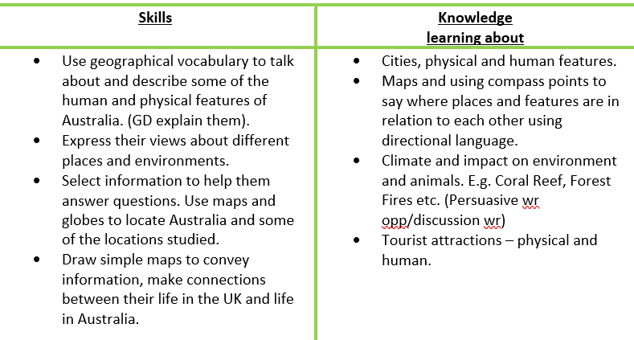 | Name, locate and identify characteristics of the four countries and capital cities of the UK and its surrounding seas (locational)
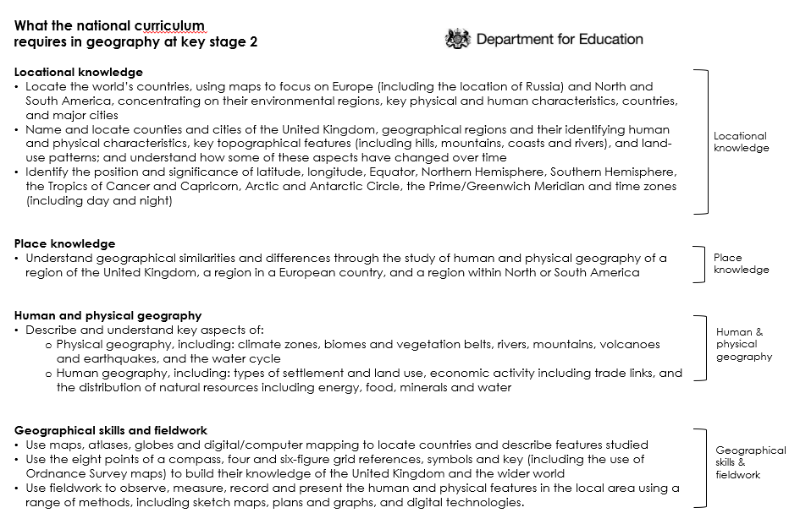
Revisit:
7 continents and 5 oceans,
China (Place)
Compass points.
Name, locate and identify characteristics of the four countries and capital cities of the UK and its surrounding seas (locational)

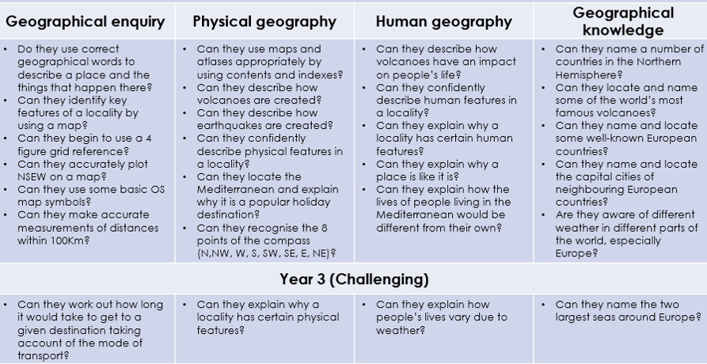
Y3 | Stone Age to Iron Age  CONTINUITY AND CHANGE  HISTORICAL EVIDENCE  AU1 and some of AU2 | Europe  LOCATION AND PLACE  PLANNING AND DECISION MAKING  AU2 and SP1 |  |  | Ancient Egypt  Historical Evidence  SP2 | Volcanoes, Earthquakes and Mountains CAUSE AND EFFECT  SU1 and some SU2 |  | Europe: Greece/Italy  LOCATION AND PLACE  CHANGE  SU2
 |  | 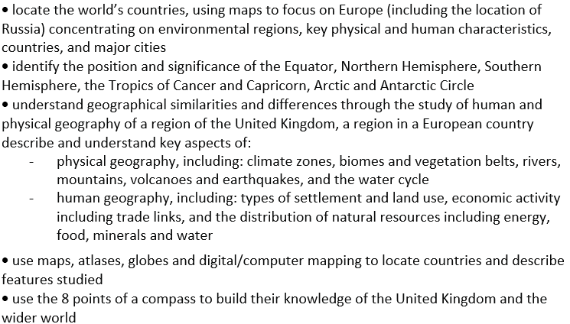  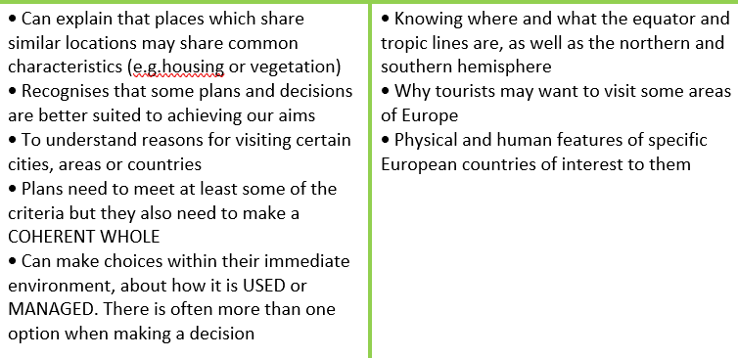  Digimaps  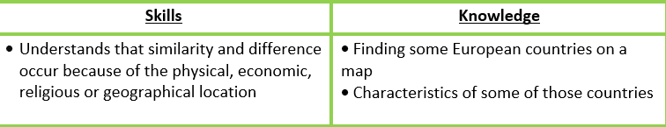  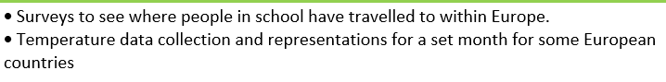 |  |  |  | 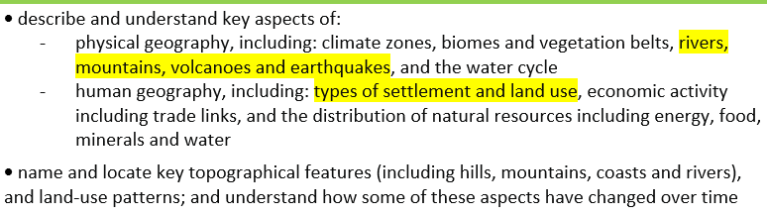  Digimaps  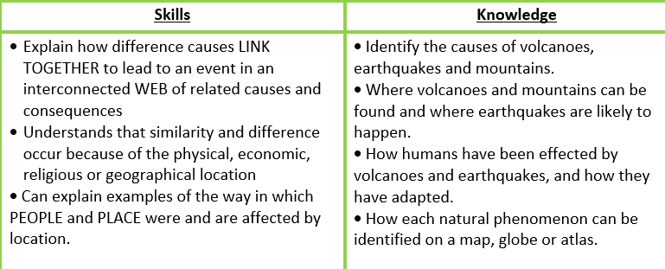  Use secondary data to:  Research population trends before and after the eruption in Pompeii.  Research population numbers for villages/towns near a mountain range/earthquake belt/volcano and compare with Newburn. |  | 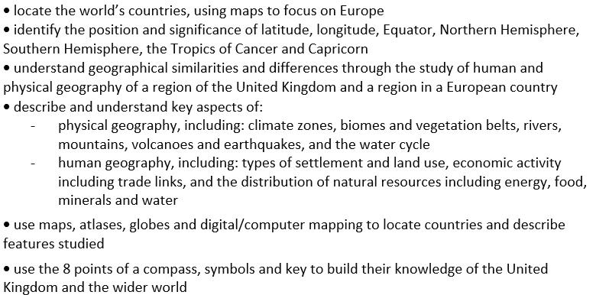  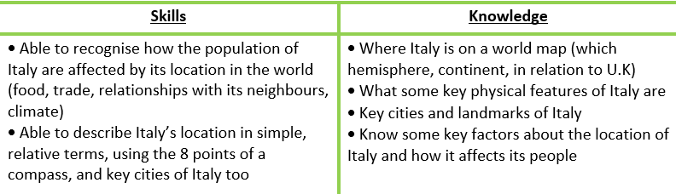  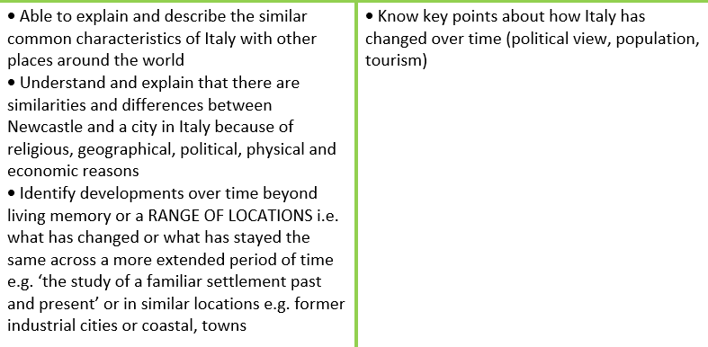  • Collect secondary data about a ‘change’ topic of choice (population, tourism figures, climate) and identify change  Digimaps
Revisit:
Volcanoes, Earthquakes, Mountains (Human and Physical).
Name, locate and identify characteristics of the four countries and capital cities of the UK and its surrounding seas (locational)

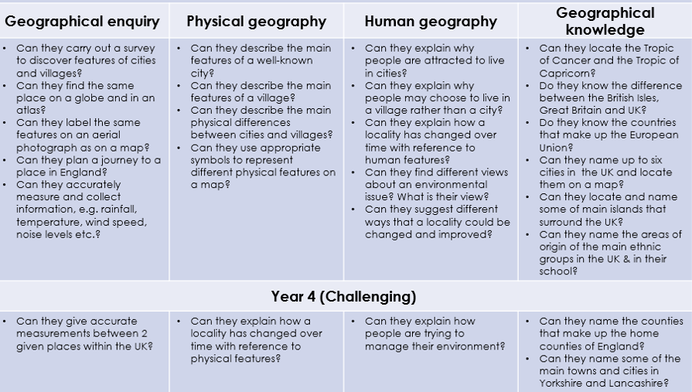
Y4 | The Romans  CAUSE AND CONSEQUENCE  SIGNIFICANCE | Rivers – Water Cycle  SYSTEMS AND PROCESSES | Anglo Saxons  SIGNIFICANCE  HISTORICAL EVIDENCE |  | The UK  LOCATION AND PLACE  SYSTEMS AND PROCESSES |  | WW2  CAUSE AND CONSEQUENCE  SIGNIFICANCE |  | Rivers  LOCATION AND PLACE  CHANGE  PLANNING AND DECISION MAKING
 |  | 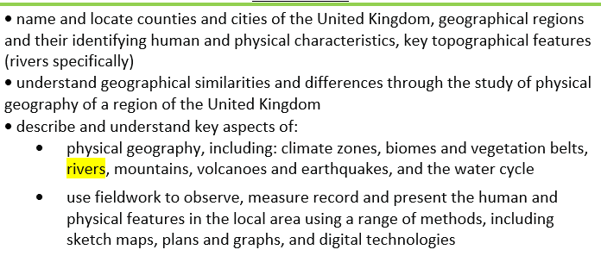  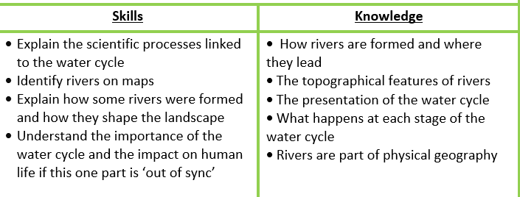  Visiting different points of the Tyne and create field sketches to compare and contrast  • Use digimaps to map out a route for key points to visit  • Measure how fast the river flows at different points – use a biodegradable material to put in the river. |  |  | 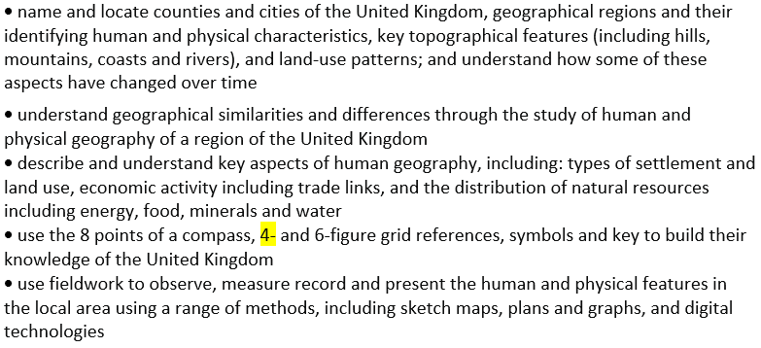  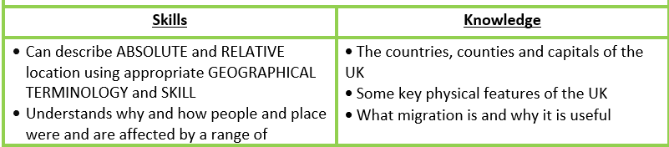  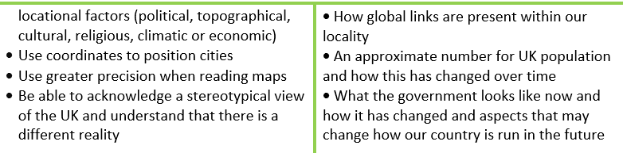  Digimaps  Secondary research of migration figures or population numbers  • Conducting interview research |  |  |  | 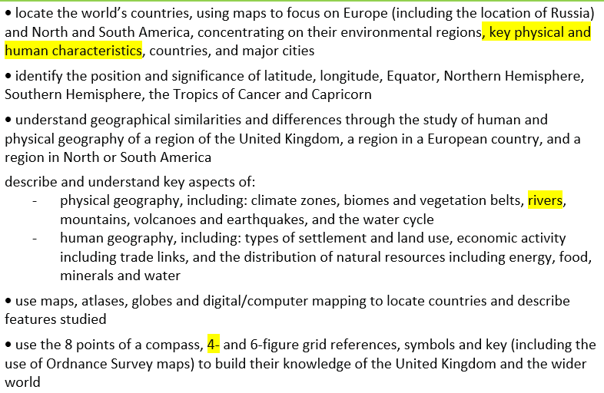  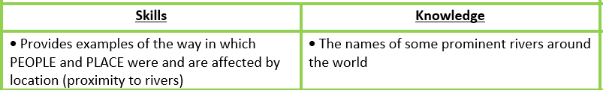  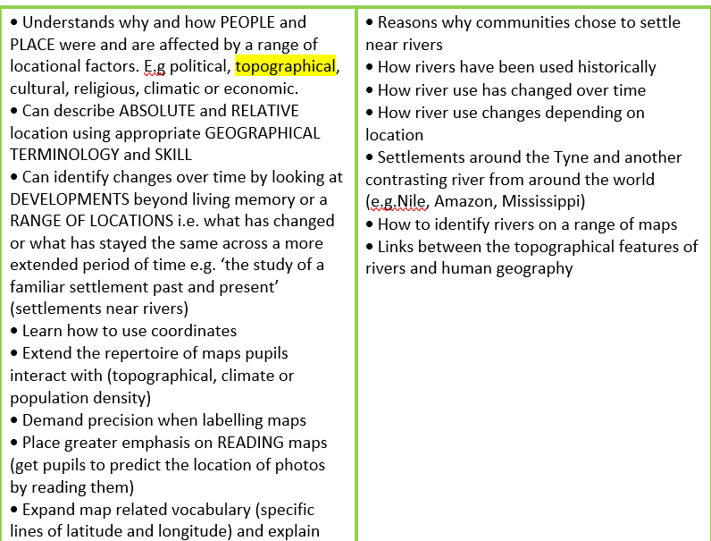  Digimaps  Visiting the river to take a survey of pollution – is there any? What can we see at different points?  • Secondary research to plot change in river use over time
Revisit:
7 continents and 5 oceans
Capital cities
Flags
Counties and cities of the UK
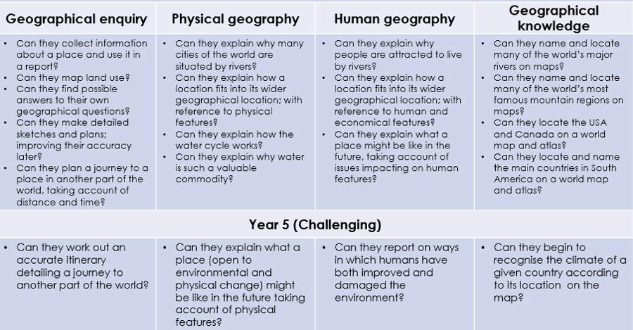
Y5 | Mayans  HISTORICAL EVIDENCE | Rainforests: Brazil  SYSTEMS AND PROCESSES  LOCATION AND PLACE  CHANGE | Rainforests | Tudors | Tudors  SIGNIFICANCE  HISTORICAL EVIDENCE |  | Food for Thought  LOCATION AND PLACE  CAUSE AND EFFECT |  | Food for Thought
 |  | Emma Espley Amazon online.  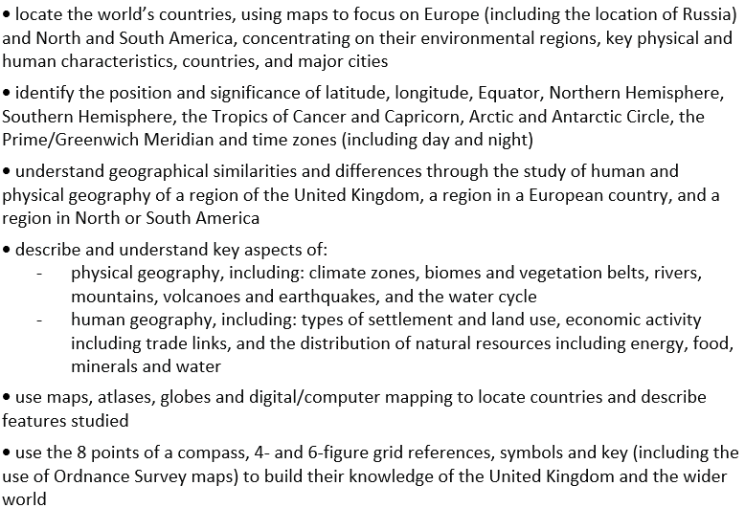  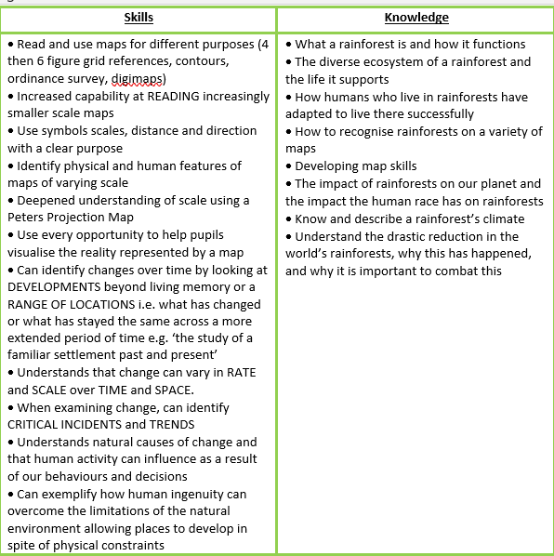  Weather diaries (using secondary research) of two different rainforest around the world |  |  |  |  | 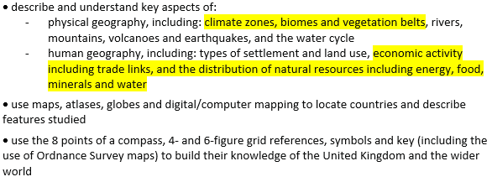  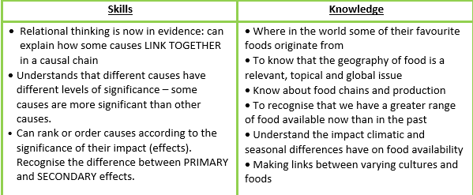  • Researching where particular foods come from. Try sticking to one food group to show relative comparison.  • Complete parent/pupil surveys of favourite foods, showing influence from around the globe.
Revisit:
Rainforests (Place) (Human and Physical).
Volcanoes, Earthquakes, Mountains (Human and Physical).
Polar Regions (Place)

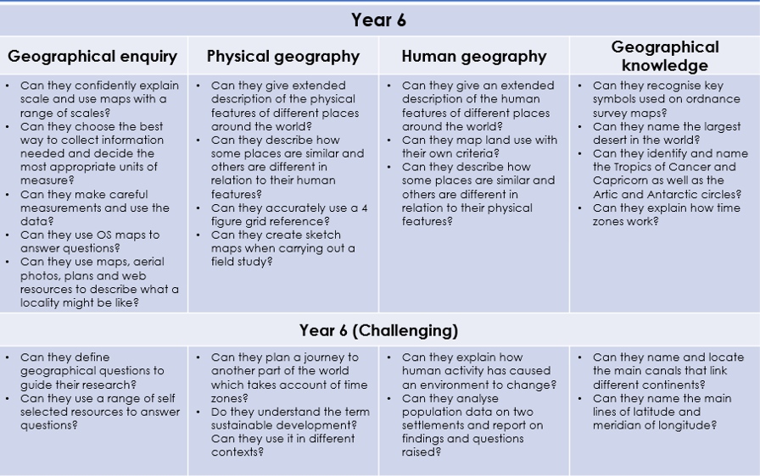
Y6 | Ancient Greece  SIGNIFICANCE  HISTORICAL EVIDENCE | North America  LOCATION AND PLACE  CHANGE | North America | Victorians | Victorians  SIGNIFICANCE  CONTINUITY AND CHANGE |  | The North  LOCATION AND PLACE  CHANGE |  | The North  CAUSE AND CONSEQUENCE
 |  | 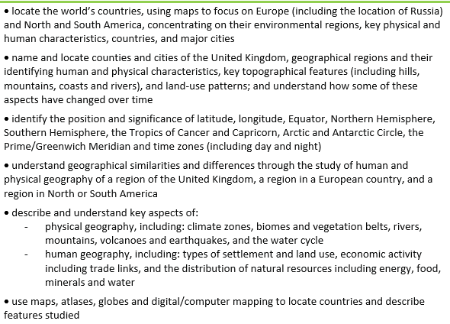  use the 8 points of a compass, 4- and 6-figure grid references, symbols and key (including the use of Ordnance Survey maps) to build their knowledge of the United Kingdom and the wider world  Weather diaries using secondary research  • River studies using digimaps |  |  |  |  | 

