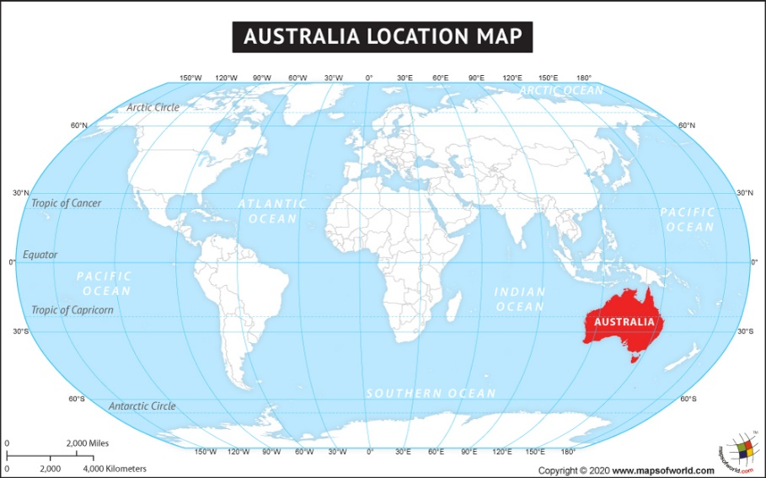
Map and Overview
- Australia is a country in the Southern Hemisphere.
- It is made up of the mainland Australian continent, the island of Tazmania and several smaller islands.
- Along with thousands of Pacific Islands, it makes up the geographical region of Oceania.
- Australia is the 6th largest country in the world.
- About 25.7 million people live in Australia.
- Due to its large size, Australia is one of the most sparsely populated large countries in the world.

Geography
Topic: Australia Yr grp: 2

Key Vocabulary
Canberra | the capital of Australia
city | an urban area where a large number of people live and work
climate | the general weather conditions of an area over a prolonged period
coastal | an area of land close to the sea
continent | any of the large landmasses in the world
Europe | The continent that we live in
human geography | a geographical feature which has been created by humans, often for a purpose
landmarks | A building or feature which is easily recognised.
Pacific Ocean | The largest and deepest ocean lying between Asia and Australia.
physical geography | a geographical feature which has been created naturally
population | number of people that live in a country or area.
river | a large, natural stream of fresh water that flows into the sea or a lake
Sydney | A large city in Australia
Physical Geography |  | Human Geography
Uluru | Uluru, or Ayers Rock, is a massive sandstone monolith in the heart of the Northern Territory’s arid "Red Centre".  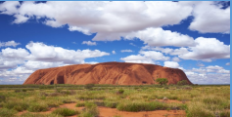 | Sydney Harbour Bridge | A steel-arch bridge across Sydney Harbour Australia. The bridge, opened in 1932, It spans about 500 metres (1,650 feet), making it one of the longest steel-arch bridges in the world. Along its length, it features four railroad tracks, a highway, and two pedestrian walkways.  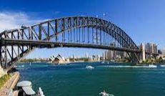
The Great Barrier Reef | The Great Barrier Reef is the world's largest coral reef system made up of over 2,900 individual reefs and 900 islands. The reef is located in the Coral Sea, off the coast of Queensland, Australia.  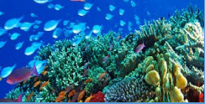 | Sydney Opera House | The Sydney Opera House is a multi-venue performing arts centre at Sydney Harbour located in Sydney, New South Wales, Australia. It is one of the 20th century's most famous and distinctive buildings.  

