Topic: Earth and Space Yr grp: 5
Key Vocabulary
axis | an imaginary line through the middle of something, which something rotates
galaxy | an extremely large group of stars and planets. Our galaxy is called the Milky Way.
gravity | the force which causes things to drop to the ground
gravitational | moving towards a centre of gravity
orbit | the curved path in space that is followed by an object going a planet, moon, or star
planet | a large, round object in space that moves around a star
rotating | moving in a circle around an axis
shadow | a dark shape on a surface that is made when something stands between a light and the surface
solar | relating to the Sun
Solar System | the Sun and all the planets that go round it
star | a large ball of burning gas in space
time zones | one of the areas into which the world is divided where the time is calculated as being a particular number of hours behind or ahead of GMT (Greenwich Mean Time)
universe | the whole of space and all the stars, planets, and other forms of matter and energy in it
The Rotation of the Earth
How else does the Earth move? | • The Earth spins on its own axis.  • The Earth takes 24 hours (1 day) to completely rotate on its axis.
What causes day and night? | • The Earth spins once in a day.  • The side of the Earth facing the Sun is in daytime.  • The side of the Earth facing away from the Sun is in night time.
What causes Sunrise and Sunset? | • The Sun doesn’t move - it is us that moves.  • Because the Earth is rotating, the Sun appears to move across the sky as the day goes on.

The Earth and The Sun
What is the Sun? | • The sun is a star at the centre of our solar system.
What is the solar system? | • The solar system has eight planets; Mercury, Venus, Earth, Mars, Jupiter, Saturn, Uranus and Neptune.
How is the Earth related to the Sun? | • The Earth orbits (goes around) the Sun.  • The Earth takes one year to orbit the Sun.  • The Earth is held in its orbit round the Sun by the Sun’s gravitational pull.

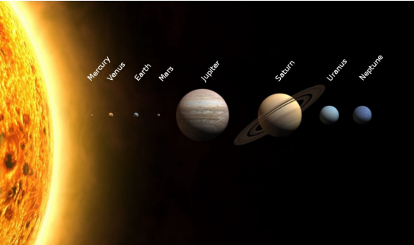
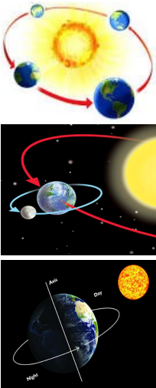
WARNING: IT IS NOT SAFE TO EVER LOOK DIRECTLY AT THE SUN, EVEN WHEN WEARING SUN GLASSES.
The Earth and The Moon
What is a moon? | • A moon is a celestial body that orbits a planet.  • The Earth has one moon; Jupiter has four large moons and numerous small ones.
How is the Moon related to the Earth? | • The Moon orbits the Earth.  • It takes about 28 days for the Moon to orbit the Earth.  • The Moon is held in its orbit round the Earth by the Earth’s gravitational pull.
Why does the Moon change shape? | • IT DOESN’T.  • It appears to change shape because we cannot always see the side of the Moon that’s in sunlight or we can only see part of the sunlit side of the Moon as it orbits Earth.

The Earth orbiting the Sun, which takes one year.

The Moon orbiting the Earth, which takes about 28 days.

The Earth spinning on its axis, which takes 24 hours.

