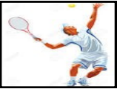
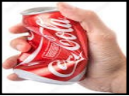
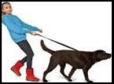
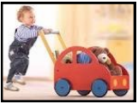
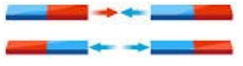
Forces
What is a force? | A force is either:  • A push or  • A pull
Forces can make things... | • Speed up  • Slow down  • Change shape  • Change direction
A force that speeds something up | The child is pushing  the car to speed it up.
A force that slows something down | The girls is pulling the  dog to slow it down.
A force that changes the shape of something | The can is being squeezed so  that it changes shape and  becomes smaller.
A force that changes the direction of something | When the ball is hit with the  racket, it will change direction.

Types of Forces
Magnetism:  Magnets attract or repel each other or other objects | Attract:  Repel:  North and South attract. But North and North or South and South will repel.
Air Resistance | • Slows down moving objects, because air slows you down as you move through it  • To travel faster through the air, things need to be streamlined.
Water Resistance | • Slows down moving objects, because water slows you down as you move through it  • To travel faster through the water, things need to be streamlined.
Friction | • Friction happens when two surfaces touch each other.  • Friction gives us grip.  • Friction produces heat.  • Rougher surfaces slow things down a lot.  • Smoother surfaces don’t slow things down as much.
Gravity
What is gravity? | • Gravity is the forces that pulls objects down towards the centre of the Earth.  • Gravity stops things from floating away into space.  • When things go into the air (like a football) gravity pulls them back down.

Science
Topic: Forces Yr grp: 5
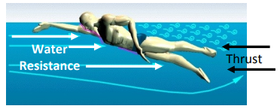
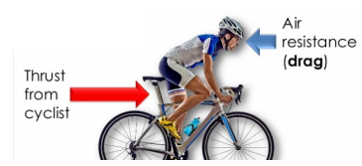
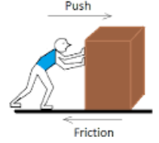
Key Vocabulary
attract | if one object attracts another object, it causes the second object to move towards it
centre | the middle
drag | to cause to slow down
gear | a part of a machine that causes another part to move because of teeth which connect the two moving parts
grip | to have a good connection with a surface
lever | a basic tool used to lift or pry things open
motion | the activity of changing position or moving from one place to another
opposite | used to describe things of the same kind which are completely different in a particular way
pulley | a simple machine that makes lifting something easier. A pulley has a wheel or set of wheels with grooves that a rope or chain can be pulled over
repel | when a magnetic pole repels another magnetic pole, it gives out a force that pushes the other pole away
resistance | a force which slows down a moving object or vehicle
spring | a spiral of wire which returns to its original shape after it is pressed or pulled
streamlined | a streamlined vehicle, animal, or object has a shape that allows it to move quickly or efficiently through air or water
surface | the top layer of something


