Key Vocabulary
condensation | small drops of water which form when water vapour or steam touches a cold surface, such as a window
conductor | a substance that heat or electricity can pass through or along
dissolves | when a substance is mixed with a liquid and the substance disappears
evaporation | to turn from liquid into gas; pass away in the form of vapour
filtering | a device used to remove dirt or other solids from liquids or gases. A filter can be made of paper, charcoal, or other material with tiny holes in it
gas | a form of matter that is neither liquid nor solid
irreversible | cannot be undone or reversed
liquid | in a form that flows easily and is neither a solid nor a gas
properties | a specific quality of something
reversible | can be undone or reversed
separating | the act of moving things apart
solid | having a firm shape or form that can be measured in length, width, and height; not like a liquid or a gas
substance | any material that has physical properties
Science
Topic: Properties and Changes of Materials Yr grp: 5
Spencer Silver
• American scientist who created the glue for sticky notes.
• He tried to make a new super glue but instead made a very weak solution which was used for sticky notes.
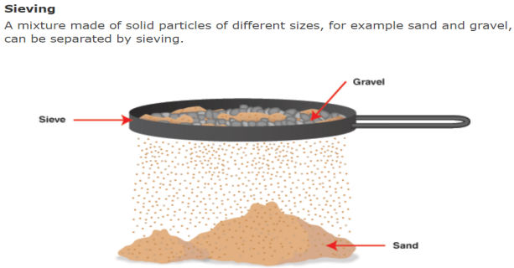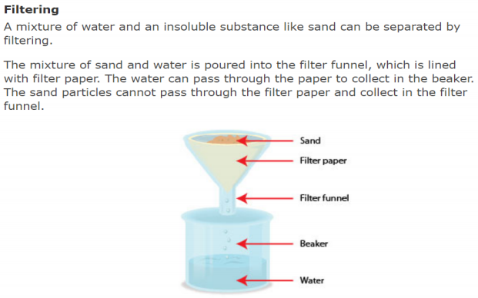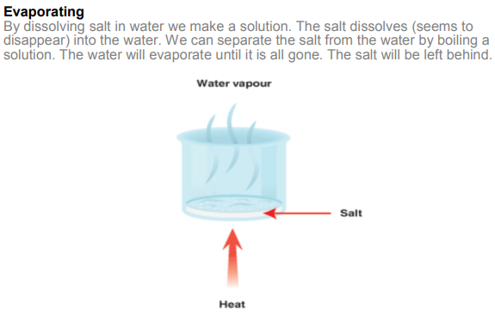
Comparing and Grouping Materials
Materials can be grouped by their properties (is it hard or soft?) or by more than one of their properties (is it hard and magnetic?).
Properties of materials we can compare
Hard | • Difficult to scratch, like the head of a hammer.
Soft | • Easy to shape, like fabric.
Soluble | • Can be dissolved, like coffee granules.
Insoluble | • Cannot be dissolved, like pebbles.
Transparent | • See through, like glass.
Opaque | • Not see through, like a wooden door.
Electrical conductor | • Allows electricity pass through easily, like copper wire.
Electrical insulator | • Do not let electricity flow through easily, like plastic or rubber.
Thermal conductor | • Allows heat pass through easily, like a metal kettle.
Thermal insulator | • Does not let heat pass through easily, like a wood pan handle.
Magnetic | • Is attracted to a magnet, like a steel spoon. Note: Not all metals attract to magnets.
Not magnetic | • Is not attracted to a magnet, like a wooden spoon.
Reversible and Irreversible Changes
What is a reversible change? | • A change that doesn’t last forever. For example, water can turn to ice when frozen, but can be turned back to water by heating it.
What is an irreversible change? | • Lasts forever  • Usually caused by heat.  • E.g. Eggs, flour, butter and sugar heated to make a cake. The original ingredients can’t be recovered.
Mixtures and Solutions
A mixture | • Where substances are mixed together, but dissolving hasn’t taken place. For example, mixing, cucumber slices, egg slices and tomato slices to make a salad.
A solution | • Some substances dissolve in a liquid. When this happens the liquid is called a solution. For example, when gravy granules dissolve in water, this is a solution.
Separating a Mixture
We can separate a mixture by sieving and/or filtering | • Sieving - sorting out the big bits from the small bits, e.g. stones from soil.  • Filtering - separating solid bits from a liquid, e.g. sand from sand and water
Separating a Solution
We can separate a solution by evaporation | • Because the soluble substance is too mixed into the water, it can’t be removed by sieving or filtering.  • Evaporation - A liquid evaporates into a gas when it is heated. This removes the liquid and leaves the substance behind.

