Science
Topic: Plants Yr grp: 2
Key Vocabulary
branches | parts that grow out from the tree trunk and have leaves, flowers, or fruit growing on them
bulb | a root shaped like an onion that grows into a flower or plant
deciduous | a tree that loses its leaves in the autumn every year
evergreen | a tree or bush which has green leaves all the year round
flowers (blossom) | the part of a plant which is often brightly coloured and grows at the end of a stem
flowering plants | trees or plants which produce flowers
fruit | something which grows on a tree or bush and which contains seeds or a stone covered by a substance that you can eat
germination | the process of a seed starting to grow
leaves | the parts of a tree or plant that are flat, thin, and usually green
nutrients | found in food and help animals and plants grow and stay healthy
petal | thin, coloured or white parts which form part of the flower
plant | a living thing that grows in the earth and has a stem, leaves, and roots
reproduce | when an animal or plant produces one or more individuals similar to itself
roots | the parts of a plant that grow under the ground
seed | the small, hard part from which a new plant grows
stem | the thin, upright part of a plant on which the flowers and leaves grow
tree | a tall plant that has a hard trunk, branches, and leaves
trunk | the large main stem from which the branches grow
vegetable | plants such as cabbages, potatoes, and onions which you can cook and eat
vegetation | plants, trees and flowers
weed | a wild plant that grows in garden and prevents the plants that you want from growing properly

Plants need water, light and a sustainable temperature to grow and stay healthy | Plants require things such as water, warmth, nutrients from soil and light to grow.  If they do not have one or more of these things, they may stop growing.  Plants can:  - move  - grow  - react to their surroundings (sense)  - absorb nutrients  - reproduce
Describe how seeds and bulbs grow into mature plants | A seed germinates and grows into a plant.  A flower grows which can produce seeds/fruit.  A fruit with seeds is left behind.  The seeds get scattered by the wind/insects.  The process begins again.  This is called the life cycle of a plant.
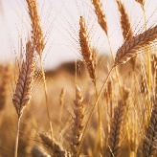  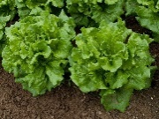  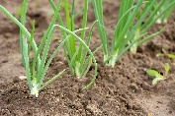  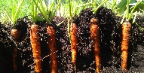  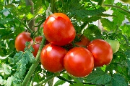  Are plants important to humans? | Many plants provide us with food by bearing fruits which carry their seeds.  When farmers grow plants to provide us with food, these are called crops.  We eat many fruits that contain seeds.  We also eat different parts of vegetable plants:  root vegetables (carrots, potatoes)  stem vegetables (celery, spring onion)  leafy vegetables (cabbage, lettuce)  flowering vegetables (cauliflower, broccoli)  We eat grains and cereals from plants too (wheat, oats).  Nuts and seeds are also sometimes edible (sesame seeds, pumpkin seeds, peanuts).  Many herbs are also grown to add flavour to foods.


