Science
Topic: Animals, inc Humans Yr grp: 2
Key Vocabulary
adult | a grown up
bacteria | a tiny living microorganism, which can be bad for you
balanced diet | a variety of food that you regularly eat to maintain health
bar chart | a chart which uses bars to represent the value of something and comparing it to a different group
baby | a very young child
child(ren) | a young person below the age of 13
exercise | when you exercise, you move your body in order to get fit and to remain healthy
elderly | an older adult
growth | the process of getting bigger
healthy | well and not suffering from any illness
hygiene | keeping yourself and your surroundings clean, in order to stop spreading germs and bacteria
life cycle | the series of changes that an animal or plant passes through from the beginning of its life until its death
muscles | something inside your body which connects two bones and which you use when you make a movement
offspring | a person's children or an animal's child or children
pupa | An insect that is about to turn into an adult
spawn | many eggs of an animal, such as a frog or fish
survive | continue to exist
toddler | a young child that is just beginning to walk
teenager | a person aged between 13 and 19

What is a life cycle?  Link to Polar topic and polar animals | Animals become older and change as time passes – this is called a life cycle. Animals, including humans, have offspring which grow into adults.  3 examples of animal growth:  Egg > chick > chicken  Egg > caterpillar > pupa > butterfly  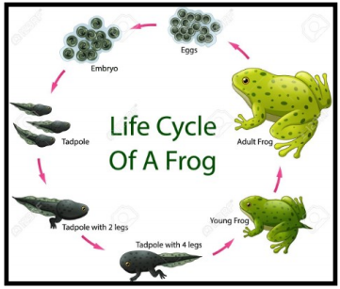  Spawn > tadpole > frog  Human growth:  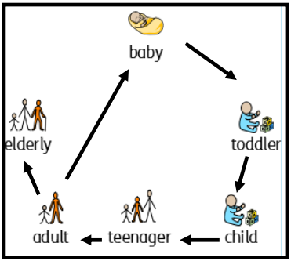  Baby > toddler > child > teenager > adult > elderly
What do all animals (humans, too) need to survive?

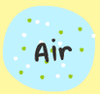
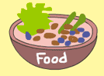
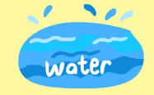

It could also be said that shelter is needed to survive.
What do humans need to be healthy?
Things humans need to be healthy | • To have a balanced diet of the right amount of different types of food and drink.  • To exercise regularly.  • To be hygienic.
What is a balanced diet? | • See the Eatwell Guide  • Drink 6-8 cups/glasses of fluids each day
What is regular exercise? | Adults needs to be active for at least 150 minutes each week  • Children aged 5 to 16 need to be active for at least 60 minutes each day  • Children under 5 need 3 hours of activity a day
What is good hygiene? | To maintain daily personal hygiene, you should make sure:  • your hands are washed after you've used the toilet  • your face is washed daily  • you're fully bathed or showered daily  • your teeth are brushed twice a day


