Science
Topic: Uses of Everyday Materials Yr grp: 2
Key Vocabulary
absorbent | material that soaks up liquid
bendy | an object that bends easily into a curved shape
brick | rectangular blocks of baked clay used for building walls, which are usually red or brown
dull | a colour or light that is not bright
elastic | a rubber material that stretches when you pull it and returns to its original size and shape when you let it go
fabrics | cloth or other material produced by weaving together cotton, wool or other threads
foil | sheets of metal as thin as paper
glass | a hard transparent material
man-made | things are created by people
material | the ‘stuff’ an object is made out of
metal | a hard substance such as iron, steel, gold, or lead
natural | things that exist in nature and are not made by people
opaque | not able to see through
plastic | a material which is light in weight and does not break easily
rock | the hard substance which the Earth is made of
rough | uneven and not smooth
shiny | reflects light easily
smooth | smooth no roughness, lumps, or holes
soft | not rough or hard
stiff | firm or does not bend easily
stretchy | can be made longer or wider without breaking
surface | an outside part or layer of something
transparent | if an object is transparent, you can see through it
waterproof | does not let water pass through it
wood | wood the material which forms the trunks and branches of trees
What is a material? | All objects have a name like ’a door’. Material is the ‘stuff’ an object is made from.
Properties of Materials
wood | hard, strong, stiff
plastic | strong, shiny, flexible
glass | transparent, smooth, stiff
metal | hard, strong, shiny, flexible
brick | hard, strong, opaque
rock | hard, strong
paper | flexible, absorbent
cardboard | hard, flexible
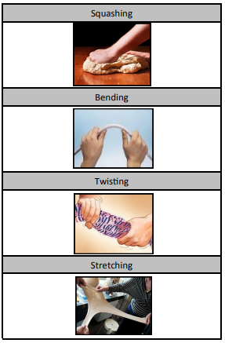
Common Uses for Everyday Materials
wood |   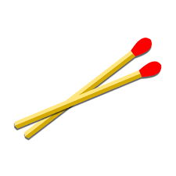  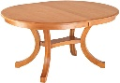  matches, flooring, table
plastic | 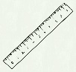    pen, ruler
glass |   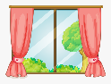  window pane, spectacles
metal | 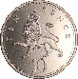  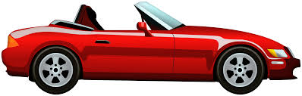  cars, coins
brick | 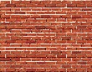    houses, walls
rock | 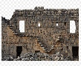  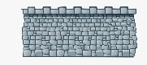  walls, buildings
paper | 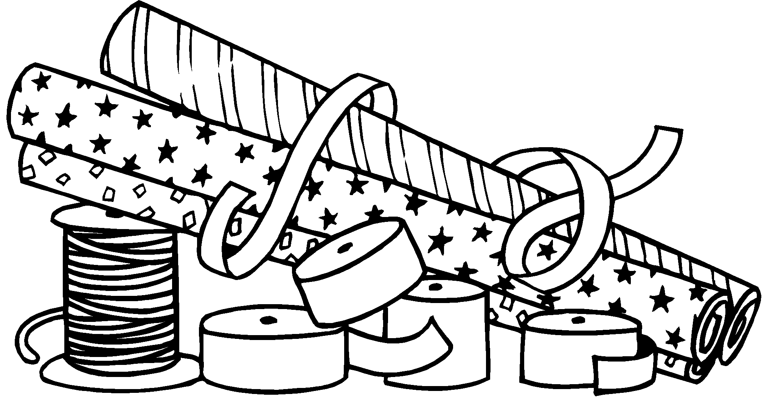  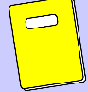  school book, wrapping paper
cardboard | 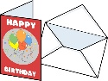    folders, birthday cards
Some objects can be made from different materials. For example, a spoon can be made from wood, metal or plastic, but not normally from glass.
Squashing
Crush something so that it becomes flat, soft, or out of shape.
Bending
Changing a straight object so that it is curved.
Twisting
Change the shape of an object by turning it.
Stretching
Made longer or wider without tearing or breaking
Experts in the Field
John Dunlop | • Born in 1840  • An expert in rubber  • Invented the first inflatable tyre.
Charles Macintosh | • Born in 1766  • Invented the first waterproof fabric  • The ‘mac’ raincoat is named after him.
John McAdam | • Born in 1756  • He invented building roads with a smooth, hard surface.

