Science
Topic: Living Things and Their Habitats Yr grp: 2
Key Vocabulary
carnivore | an animal that eats only meat
excretion | getting rid of waste materials
food chain | the order in which living things depend on each other for food
growth | getting bigger
habitat | the home of an animal or a plant
herbivore | an animal that only eats plants
microhabitat | a small part of the environment that supports a habitat, such as a fallen log in a forest
minibeast | a small animal such as an insect or spider
movement | the act of moving
nutrition | getting or making food
omnivore | an animal that eats meat and plants
reproduction | creation of new plants (seeds) or animals (babies)
respiration | creation of energy from breathing / converting oxygen / carbon dioxide
sensitivity | sensing and resounding to the environment. E.g. respond to changes in light, heat or sound
source | where something comes from

How do I know if something is alive or not? | There are 7 life processes:  Movement,  Respiration,  Sensitivity,  Growth,  Reproduction,  Excretion and  Nutrition.  These can be remembered using the acronym: MRS GREN.  If something does the above, it is alive.
Habitats
• A habitat is a place where living things can find all of the things they need to survive. This includes food, water, air, space to move and grow and some shelter.
• Some habitats are large, like the ocean, and some are very small, like under a log.
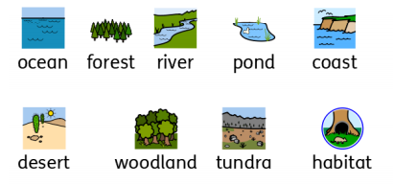
• Some habitats in our local area include the river and woodlands. Other habitats include the coast and the forest.

Microhabitats
• ‘Micro’ means very small, so a microhabitat is a very small place that things live.
• Microhabitats can be in grass, under a stone or fallen leaves (for example).
• Minibeasts tend to live in these places.
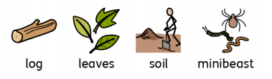

Why do certain animals/plants live in certain places? | Animals and plants are specially adapted to live in their habitats.  For example:  • a fox has teeth which are adapted to the food it eats within its habitat  • a plant has the ability to grow towards the sunlight.
How are plants and animals linked?  Link to Geog Polar Regions and Australia topics. | Living things in a habitat depend on each other for survival.  A food chain shows how each animal gets its food. The chain will always start with a plant.  

