Key Vocabulary
backbone | the column of small linked bones down the middle of your back
cold-blooded | a body temperature that changes according to the surrounding temperature
environment | all the circumstances, people, things, and events around them that influence their life
farm | an area of land used to produce crops or to breed animals and livestock
gills | the organs on the sides of fish and other water creatures through which they breathe
pet | a tame animal kept in a household
vertebrate | a creature which has a backbone
warm-blooded | a fairly high body temperature which does not change much and is not affected by the surrounding temperature
wild | animals or plants that live or grow in natural surroundings
Animals
6 types of animals | • Invertebrates  • Fish  • Amphibians  • Reptiles  • Birds  • Mammals
Some common invertebrates | • Crab, jellyfish, worm
Some common fish | • Goldfish, cod, shark
Some common amphibians | • Frog, toad, newt
Some common reptiles | • Snake, crocodile, lizard
Some common birds | • Sparrow, chicken, owl
Some common mammals | • Human, dog, lion
Animals that eat meat | Animals that eat other animals are called carnivores
Animals that eat plants | Animals that eat plants are called herbivores
Animals that eat meat and plants | Animals that eat both plants and other animals are called omnivores
Some common carnivores | Lion, tiger, brown bear
Some common herbivores | Cow, sheep, rabbit
Some common omnivores | Human, pig, rat
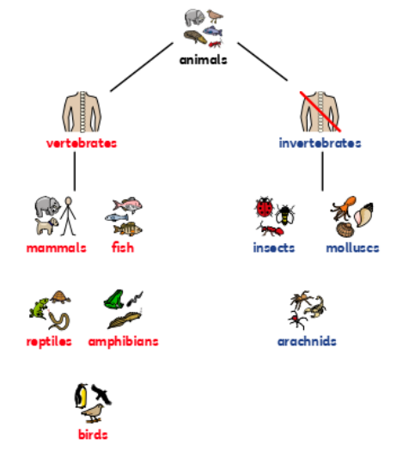
Science
Topic: Animals inc. Humans Yr grp: 1
Types of Animals
Vertebrates | Animals with a backbone
Invertebrates | Animals with no backbone
Fish (mostly cold-blooded) | An animal with gills and fins that lives in water
Amphibians (cold-blooded) | An animal which can live on land or in water
Reptiles (cold-blooded) | An animal which has dry, scaly skin and lays eggs on land
Birds (warm-blooded) | An animal with feathers, wings and a beak that is usually able to fly
Mammals (warm-blooded) | An animal that feeds its young with milk from the mother and has skin usually more or less covered with hair
Pet | A friendly animal trained to live with humans

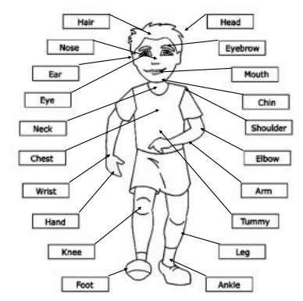
Humans
Human beings | • We are called humans  • We are from the family of animals called mammals
Basic parts of the human body | Hair, head, ears, eyebrows, eyes, nose, mouth, chin, neck, shoulder, chest, elbow, arm, wrist, hand, tummy, knee, leg, ankle and foot.
There are 5 basic human senses. | Touch, taste, smell, sight and hearing.
How do we touch? | We touch using our skin (usually our hands).
How do we taste? | We taste by putting something in our mouth..
How do we smell? | We smell by using our nose..
How do we see? | We see by using our eyes.
How do we hear? | We hear by using our ears.

