Science
Topic: Everyday Materials Yr grp: 1
Key Vocabulary
absorbent | material that soaks up liquid
bendy | an object that bends easily into a curved shape
brick | rectangular blocks of baked clay used for building walls, which are usually red or brown
dull | a colour or light that is not bright
elastic | a rubber material that stretches when you pull it and returns to its original size and shape when you let it go
fabrics | cloth or other material produced by weaving together cotton, wool or other threads
foil | sheets of metal as thin as paper
glass | a hard transparent material
man-made | things are created by people
material | the ‘stuff’ an object is made out of
metal | a hard substance such as iron, steel, gold, or lead
natural | things that exist in nature and are not made by people
opaque | not able to see through
plastic | a material which is light in weight and does not break easily
rock | the hard substance which the Earth is made of
rough | uneven and not smooth
shiny | reflects light easily
smooth | smooth no roughness, lumps, or holes
soft | not rough or hard
stiff | firm or does not bend easily
stretchy | can be made longer or wider without breaking
surface | an outside part or layer of something
transparent | if an object is transparent, you can see through it
waterproof | does not let water pass through it
wood | wood the material which forms the trunks and branches of trees
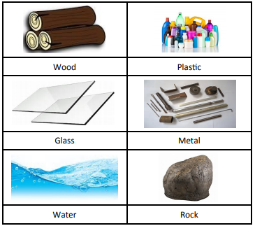
What is a material? | All objects have a name like ’a door’. Material is the ‘stuff’ an object is made from.
Which materials are some objects made from? | 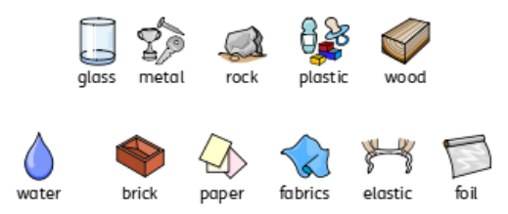
Which words can I use to describe materials? | 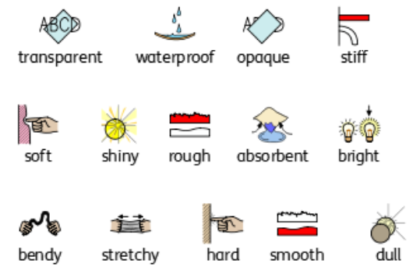
Which materials are natural? | 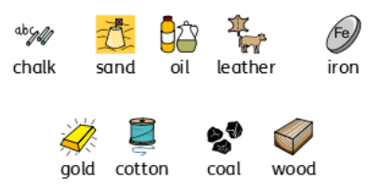  Natural materials are materials which are found in nature.
Which materials are man-made? | 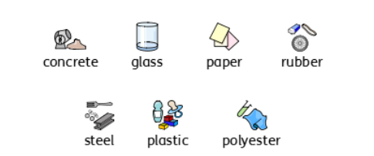  Man-made materials are materials which have been produced by humans.

