Science
Topic: Plants Yr grp: 1
Key Vocabulary
branches | parts that grow out from the tree trunk and have leaves, flowers, or fruit growing on them
bulb | a root shaped like an onion that grows into a flower or plant
common | something that is found in large numbers or it happens often
deciduous | a tree that loses its leaves in the autumn every year
evergreen | a tree or bush which has green leaves all the year round
flowers (blossom) | the part of a plant which is often brightly coloured and grows at the end of a stem
flowering plants | trees or plants which produce flowers
fruit | something which grows on a tree or bush and which contains seeds or a stone covered by a substance that you can eat
garden | a piece of land next to a house, with flowers, vegetables, other plants, and often grass
habitat | where something lives
leaves | the parts of a tree or plant that are flat, thin, and usually green
petal | thin, coloured or white parts which form part of the flower
plant | a living thing that grows in the earth and has a stem, leaves, and roots
roots | the parts of a plant that grow under the ground
seed | the small, hard part from which a new plant grows
stem | the thin, upright part of a plant on which the flowers and leaves grow
tree | a tall plant that has a hard trunk, branches, and leaves
trunk | the large main stem from which the branches grow
weed | a wild plant that grows in garden and prevents the plants that you want from growing properly
wild | animals or plants that live or grow in natural surroundings and are not looked after by people

Common Garden Plants  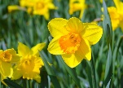  Daffodils  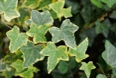  Ivy  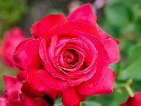  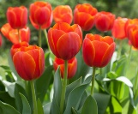  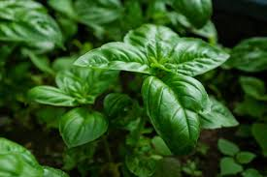  Roses  Tulips  Basil | People may grow plants in their gardens and care for them.  They may grow flowering plants which are beautiful to look at or beans and seeds to grow plants for food.  When plants are grown for food, this may be called a herb garden or vegetable patch.
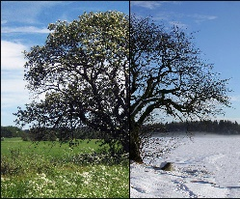  Deciduous Trees/Bushes  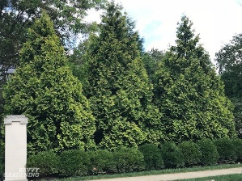  Evergreen Trees/Bushes | Deciduous trees lose their leaves in the autumn every year. Their leaves are generally broad, flat and have veins running through them.  Evergreen trees have green leaves all year round. Their leaves are generally thick, waxy and narrow like needles.
Common Wild Plants  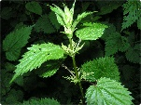  Stinging Nettles  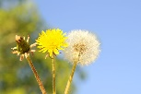  Dandelions  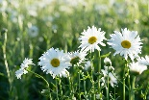  Daisies  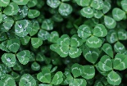  Clover  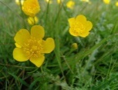  Buttercup | A wild plant will grow by itself.  It does not need to be cared for.  If it grows somewhere unwanted, it may be a weed.
Identifying and Describing the Basic Structure of Plants/Trees

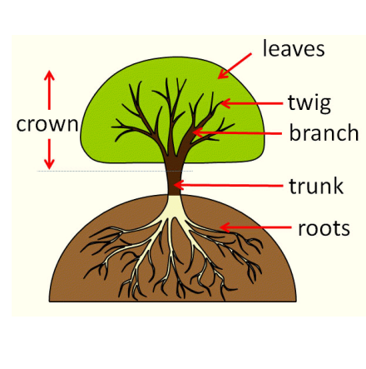 | 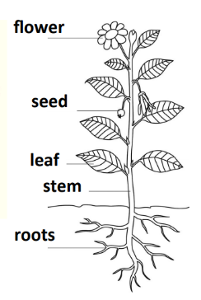
Remember…
Plants can grow from seeds and bulbs.

