What is a season?
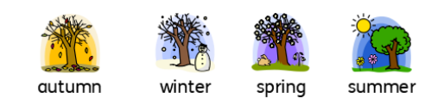
There are four seasons:
• Autumn - September, October, November
• Winter - December, January, February
• Spring - March, April, May
• Summer - June, July, August

Science
Topic: Seasonal Changes (A + W) Yr grp: 1
Key Vocabulary
autumn | season between summer and winter when the weather becomes colder and the leaves fall off some trees
chilly | very cold
cold | the temperature is very low
conkers | round brown nuts which come from horse chestnut trees
day length | the amount of time where there is daylight
daylight | the natural light that there is during the day, before it gets dark
deciduous | a tree that loses its leaves in the autumn every year
freeze | the temperature falls below 0 degrees
frost | the ground becomes covered in ice crystals
hibernate | animals that hibernate spend the winter in a state like a deep sleep
ice | frozen water
migrate | when animals move at a particular season from one part of the world to another
months | one of the twelve periods of time that a year is divided into
nature | the animals, plants, and other things in the world that are not made by people
rain | rain is water that falls from the clouds in small drops
season | the main times of year which can be divided and which have their own typical weather
slightly | a little bit
snow | soft white bits of frozen water that fall from the sky in cold weather
spring | the season between winter and summer when the weather becomes warmer and plants start to grow again
summer | the season between spring and autumn when the weather is usually warm or hot sunny when the sun is shining brightly
temperature | a measure of how hot or cold something is
warm | when there is some heat but not enough to be hot
weather | what the sky and air outside are like, such as cold or sunny
windy | when the wind is blowing
winter | the season between autumn and spring when the weather is usually cold

What happens in Autumn? | • The temperature beings to fall, which means it gets colder.  • The leaves on deciduous trees change colour and begin to fall to the ground.  • The days get shorter and the nights get longer.  • In the autumn, there are events such as Halloween and Bonfire Night.    • Things people might do are rake leaves, pick blackberries and collect conkers and pine cones.  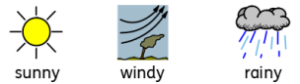  • The weather may be slightly sunny, windy or rainy. There are more clouds in the sky during autumn compared to the summer.  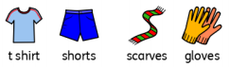  • The clothes you might wear include t-shirts and shorts on sunnier and warmer days, and woolly hats and scarves on colder days - especially as it gets closer to winter. | What happens in Winter? | • As the seasons change from autumn to winter it gets colder still - this is because the temperature has fallen.  • Sometimes, it can freeze overnight and in the mornings, there may be ice and frost.  • Deciduous trees have completely lost their leaves and the braches are bare.  • The days get shorter and the nights get longer. Winter has the shortest days and the longest nights of all the seasons.  • In the winter, there are events such as Christmas and Valentine’s Day.  • Things people might do are build snowmen, eat warm foods like stews and soups and light fires.  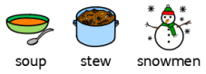  • The weather may be windy, rainy and chilly. Sometimes it also snows.  • The clothes you might wear include warm coats, jumpers, woolly hats and scarves on colder days.  

