What is a season?
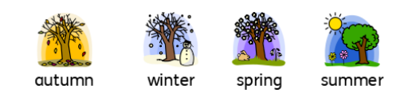
There are four seasons:
• Autumn - September, October, November
• Winter - December, January, February
• Spring - March, April, May
• Summer - June, July, August

Science
Topic: Seasonal Changes (S + S) Yr grp: 1
Key Vocabulary
autumn | season between summer and winter when the weather becomes colder and the leaves fall off some trees
blossom | the flowers that appear on a tree before the fruit
day length | the amount of time where there is daylight
daylight | the natural light that there is during the day, before it gets dark
deciduous | a tree that loses its leaves in the autumn every year
holiday | a period of time during which you relax
hot | Something that is hot has a high temperature
months | one of the twelve periods of time that a year is divided into
nature | the animals, plants, and other things in the world that are not made by people
rain | rain is water that falls from the clouds in small drops
season | the main times of year which can be divided and which have their own typical weather
slightly | a little bit
spring | the season between winter and summer when the weather becomes warmer and plants start to grow again
summer | the season between spring and autumn when the weather is usually warm or hot sunny when the sun is shining brightly
sunny | when the sun is shining brightly
temperature | a measure of how hot or cold something is
warm | when there is some heat but not enough to be hot
weather | what the sky and air outside are like, such as cold or sunny
windy | when the wind is blowing
winter | the season between autumn and spring when the weather is usually cold

What happens in Spring? | • As the seasons change from winter to spring, it gets warmer and the temperature begins to rise.  • Some things that happen in spring are: -- leaves begin to appear on deciduous trees.  - some trees begin to blossom.  - many plants begin to grow.  - lambs are born and chicks begin to hatch.  - the days become longer and the nights become shorter.  • In the spring, there are events such as Easter and St. George’s Day.  • The weather may be slightly sunny but still a little windy and rainy on some days. It may even snow!  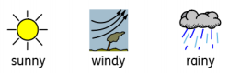  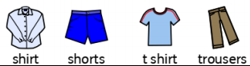  • The clothes you might wear include long-sleeved tops and long trousers. As it gets closer to summer, you may wear t-shirts and shorts on sunnier and warmer days. | What happens in Summer? | • As the seasons change from spring to summer it gets warmer still - this is because the temperature has risen.  • The days get longer and the nights get shorter. Summer has the longest days and the shortest nights of all the seasons.  • In the summer, there are events such as the long school summer holidays and music festivals.  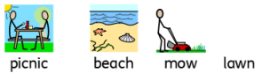  • Things people might do are have picnics, go to the beach, have a paddling pool in the garden and mow the lawn.  • The weather tends to be more hot and sunny than other times of the year.  • The clothes you might wear include t-shirts, shorts and swimming costumes.  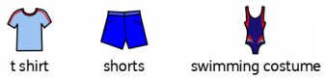  • It is important to stay safe in the summer as the sun can be very strong. You can wear sun hats, sunglasses and sun cream to help keep you safe.

