Science
Topic: Electricity Yr grp: 4
Key Vocabulary
appliances | A device or machine in your home that you use to do a job, such as cleaning or cooking. Appliances are often electrical.
battery | small devices that provide the power for electrical items, such as torches
bulb | the glass part of an electric lamp, which gives out light when electricity passes through it
buzzer | an electrical device that is used to make a buzzing sound
cell | a synonym for battery
circuit | a complete route which an electric current can flow around
component | part of something (part of a circuit)
conductor | a substance that heat or electricity can pass through or along
current | a flow of electricity through a wire or circuit
electricity | a form of energy that can be carried by wires and in used for heating and lighting, and to provide power
energy | the power from sources such as electricity that makes machines work or provides heat
fuel | a substance such as coal, oil, or petrol that is burned to provide heat or power
generate | cause it to begin and develop
insulator | a non-conductor of electricity or heat
mains | where the supply of water, electricity, or gas enters a building
motor | a device that uses electricity or fuel to produce movement
power | power is energy, especially electricity, that is obtained in large quantities from a fuel source and used to operate lights, heating, and machinery
source | where something comes from
switch | a small control for an electrical device which you use to turn the device on or off
wires | a long thin piece of metal that is used to fasten things or to carry electric current
An Electrical Circuit
A series circuit (One pathway around the circuit) | • Electricity can flow through the components in a complete electrical circuit.  • A circuit always needs a power source, such as a battery, with wires connected to both the positive (+) and negative (-) ends. (A battery is made from a collection of cells connected together).  • A circuit can also contain other electrical components, such as bulbs, buzzers or motors, which allow electricity to pass through.  • Electricity will only travel around a circuit that is complete. That means it has no gaps.
What is a switch? | • You can use a switch in a circuit to create a gap in a circuit. This can be used to switch it on and off.  • When a switch is open (off), there is a gap in the circuit. Electricity cannot travel around the circuit.  • When a switch is closed (on), it makes the circuit complete. Electricity can travel around the circuit.
Electrical Conductors and Insulators
Conductors | • Some materials let electricity pass through them easily. They are known as electrical conductors.  • Many metals, such as iron, copper and steel, are good electrical conductors.
Insulators | • Some materials do not allow electricity to pass through them. They are known as electrical insulators.  • Wood, glass, plastic and rubber are good electrical insulators. That is why they are used to cover materials that carry electricity.
WARNING: Electricity can be dangerous, so be careful when using electrical appliances.
What is electricity? | • Electricity is created by generators which can be powered by gas, coal, oil, wind or solar.  • The electrical energy can be converted into other types of energy such as light, heat, movement or sound.  • These can also be called fuel sources
What are common appliances that run on electricity? | • Some appliances use batteries and some use mains electricity.  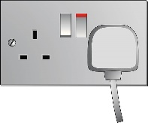  • Batteries come in different sizes depending on how much and for how long the appliance is used.  • Any appliances that need to be plugged in run on electricity.  Some common appliances that use electricity:  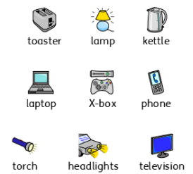
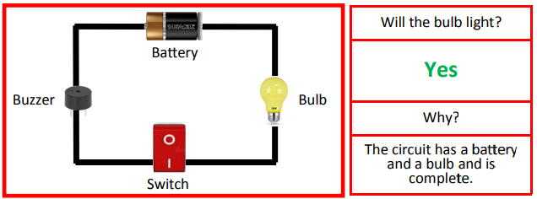
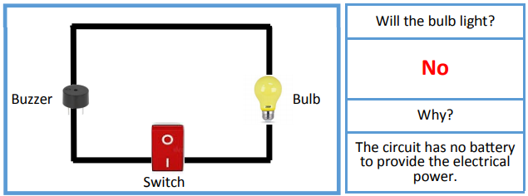

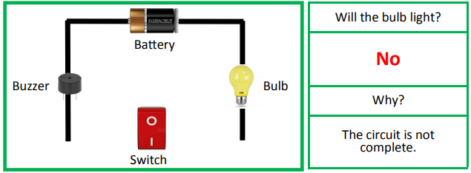
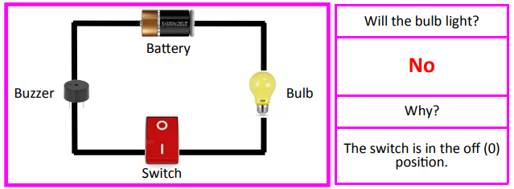
Will the bulb light?



