Science
Topic: Animals inc. Humans Yr grp: 4
Key Vocabulary
absorb | soak up or take in
enamel | the hard white substance that forms the outer part of a tooth
energy | the property that gives humans strength
excretion | the process of eliminating faeces, urine, or sweat from the body
faeces | the solid waste substance that people and animals get rid of from their body by passing it through the anus
ingested | when animals or plants ingest a substance, they take it into themselves, for example by eating or absorbing it
nutrition | the process of taking food into the body and absorbing the nutrients in those foods
organ | a part of your body that has a particular purpose
plaque | a substance containing bacteria that forms on the surface of your teeth
process | a series of actions used to produce something or reach a goal
saliva | the watery liquid that forms in your mouth and helps you to chew and digest food
waste | unwanted substances in the body
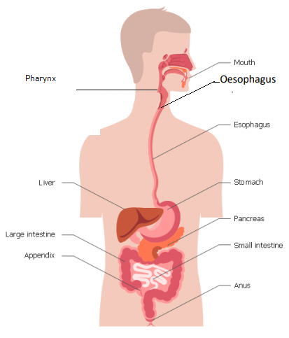
The Human Digestive
Science
Topic: Animals inc. Humans Yr grp: 4

Key Vocabulary
Topic: Animals inc. Humans Yr grp: 4
What is digestion? | Digestion is the way the body breaks down the food we eat into smaller parts that can be used to give the body energy.
The main parts of the digestive system | Mouth, tongue, pharynx, oesophagus, liver, stomach, gallbladder, pancreas, large intestine, small intestine
The digestive journey of food | • Humans put food into their mouth.  • Food is chewed by the teeth.  • Food is swallowed and passed through the pharynx and oesophagus to the stomach.  • In the stomach, it is mashed into a mixture like soup and mixed with acid.  • The mixed food is then sent to the small intestine which absorbs nutrients from the food.  • The food that is still left goes into the large intestine.  • Finally, the food minus the nutrients arrives in the rectum where muscles turn it into faeces. It is stored here until it is pushed out by the anus. This is called excretion.
Human Teeth
Teeth Facts | • Teeth grow in babies when they are about 6 months old  • 20 teeth grow by the time you are about 2.5 years old  • From about age 6 you start to lose teeth till about the age 12  • These teeth are replaced by 32 permanent teeth
Types of teeth | Incisors, Canines, Pre-Molars, Molars
Molars and Pre-molars | • Flat, back teeth for crushing and grinding food
Canines | • Long, pointed teeth for tearing and ripping food (usually meat)
Incisors | • Shovel-shaped front teeth for snipping and cutting food



