Science
Topic: Living Things and Their Habitats Yr grp: 4
Key Vocabulary
algae | a small plant that is found in water, it has no stems, roots or leaves
body temperature | how hot or cold the inside of an animals body is
carnivore | an animal that eats meat
classification key | a system which divides things into groups or types
criteria | a factor on which something is judged
deciduous | trees that lose leaves in the autumn every year
environment | all the circumstances, people, things, and events around them that influence their life
evergreen (coniferous) | a tree or bush which has green leaves all the year round
fins | part of a fish that helps it move and balance
food chain | a series of living things which are linked to each other because each thing feeds on the one next to it in the series
gills | Slits on the side of a fish to help it breathe
habitat | the natural environment in which an animal or plant normally lives or grows
herbivore | an animal that only eats plants
lungs | spongy bags in the chest used when breathing
omnivore | person or animal eats all kinds of food, including both meat and plants
scales | thin plates protecting the skin of fish or reptiles
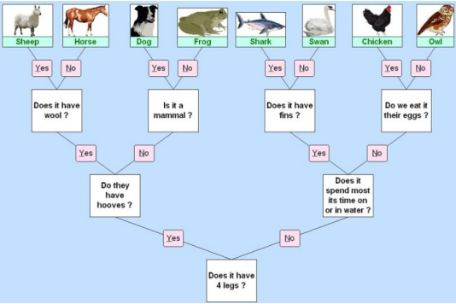
Classifying Animals and Plants
What is classifying? | Grouping things that are similar.
How can we group? | We can create branched diagrams to help us. Have a look at the diagram.

Grouping Living Things: Animals
Animals can be grouped in many different ways. Often, they are grouped depending on if they have a backbone (vertebrates) or not (invertebrates).
Vertebrates: Animals with a backbone.
There are 5 ways vertebrates can be grouped | • Fish  • Amphibians  • Reptiles  • Birds  • Mammals
How to spot a Fish | • Breathes with gills/lays eggs in water/ has fins and scales/its body temperature changes (cold-blooded)
How to spot an Amphibian | • Born with gills then develops lungs/ lays eggs in water/damp skin/body temperature changes (cold-blooded)
How to spot a Reptile | • Breathes with lungs/lays eggs on land/ dry scaly skin/body temperature changes (cold-blooded)
How to spot a Bird | • Breathes with lungs/lays eggs with hard shells/has feathers/steady body temperature (warm-blooded)
How to spot a Mammal | • Breathes with lungs/babies are born live/body hair or fur/steady body temperature (warm-blooded)/feeds babies milk
Invertebrates: Animals without a backbone
There are 3 ways Invertebrates can be grouped | • Insects  • Arachnids  • Molluscs
How to spot an Insect | • 3 body sections/6 legs
How to spot an Arachnid | • 2 body sections/8 legs
How to spot a Mollusc | • Slimy foot/often have a shell
Grouping Living Things: Plants
Plants are usually grouped into two different groups:
• Flowering plants
• Non-Flowering plants
Flowering plants can be divided into four groups | • Grasses/Cereals/Garden Shrubs/ Deciduous Trees (Lose their leaves)
Non-flowering plants can be divided into three groups | •Algae/Coniferous (Evergreen) Trees/ Ferns
Changing Habitats
What is a habitat? | Where a plant or animals lives.
How can habitats change? | The seasons can change habitats with the weather and plant life in the habitat changing. Humans can change habitats, for example by dropping litter or chopping down trees.

