Science
Topic: Sound Yr grp: 4
Key Vocabulary
amplitude | a measure of the strength of a sound wave
decibel | a measure of how loud a sound is
electricity | a form of energy that can be carried by wires and in used for heating and lighting, and to provide power for devices
energy | the power from sources such as electricity that makes machines work or provides heat
frequency | a measure of how many times per second the sound wave cycles
medium | something that makes possible the transfer of energy from one location to another
pitch | how high or low a sound is
power | power is energy, especially electricity, that is obtained in large quantities from a fuel source and used to operate lights, heating, and machinery
sound waves | invisible waves that travel through air, water, and solid objects as vibrations
source | where something comes from
transmit | to pass from one place or person to another
travel | how something moves around
vibrations | invisible waves that move quickly
volume | how loud or quiet a sound is

Sound
What is a sound? | A noise that can be heard by someone.
How is a sound made? | • A sound happens when something vibrates.  • The vibration makes the air around the object vibrate and the air vibrations enter your ear. These are called sound waves.  • If an object is making a sound, a part of it is vibrating, even if you cannot see the vibrations.      A bell ringing Blowing into a bottle
How do we hear sound?
How do sounds travel? | • Sound waves travel through a medium (such as air, water, glass, stone, and brick).  • It can travel through the air - like from a TV speaker across the room to your ears  • Through an object/material - like stone, brick, water and glass. Hearing music from your neighbour through the bricks of your home.
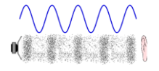  How do we hear these vibrations? | 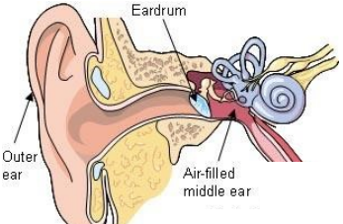  • The sound waves (vibrating air) hits our ear drums and makes them vibrate.  • The vibration is picked up by our brains and converted to sounds we recognise.
How do sounds change?
Pitch | The pitch of a sound is how high or low it is.  • A squeak of mouse has a high pitch.  • A roar of a lion has a low pitch.
Volume | The volume of a sound is how loud or quiet it is.  • When a sound is created by a little amount of energy, a weak sound wave is created which doesn’t travel far. This makes a quiet sound.  • A small tap of a hammer is used with small amounts of energy and so creates a quiet noise.  • A vibration with lots of energy makes a powerful sound wave and therefore a loud sound.  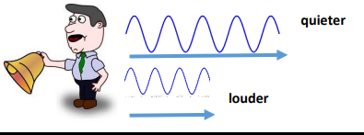  • A powerful, smashing tap of a hammer is used with lots of energy and so creates a loud noise.  • The further away you are from the source of the sound, the quieter the sound will be.
How do we measure sound?
• Amplitude measures how strong a sound wave is.
• Decibels measure how loud a sound is.
• Frequency measures the number of times per second that the sound wave cycles.


