Science
Topic: Animals, inc, Humans Yr grp: 3
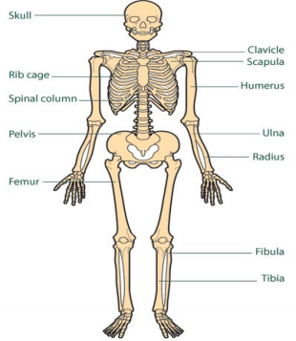

Key Vocabulary: Nutrition
balanced diet | a variety of food that you regularly eat
energy | the ability and strength to do physical things
nutrients | substances that help plants and animals to grow
nutrition | the process of taking food into the body and absorbing the nutrients in those foods
Key Vocabulary: Skeletons and Muscles
bones | the hard parts inside your body which form your skeleton
contract | to make smaller by drawing together; shrink or make tighter
endoskeleton | the internal skeleton of an animal
exoskeleton | the protective or supporting structure covering the outside of the body of many animals
joints | the join between two or more bones
muscles | something inside your body which connects two bones and which you use when you make a movement
skeleton | the framework of bones in your body
tendons | a strong cord in a person's or animal's body which joins a muscle to a bone
Skeletons and Muscles
What is a skeleton? | A skeleton is a structure of bones that supports the body of a person or animal.
12 common parts of the skeleton we should know | Skull, clavicle, scapula, rib cage, humerus, spinal column, pelvis, ulna, radius, femur, fibula and tibia (See diagram)
What is a muscle? | A soft tissue in the body that contracts and relaxes to cause movement of the skeleton
Common muscles we should know | Front: Deltoids, pectoralis major, biceps, anterior forearms, obliques, rectus abdominals, quadriceps and adductors.  Back: Trapezius, deltoids, triceps, posterior forearms, lower back, gluteals, hamstrings and calves
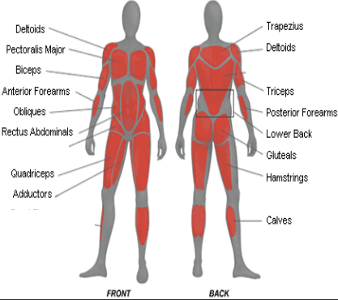
Nutrition
Things animals/humans need to survive | Water, food, air and shelter.
Things humans need to be healthy | • To have a balanced diet of the right amount of different types of food and drink  • To exercise regularly  • To be hygienic
What is nutrition? | Nutrition means getting the food needed to grow and be healthy.
Can we make our own food? | No.  • Humans and animals can’t make their own food.  • They get food by either growing it, hunting it or gathering it.
What is meant by growing food? | Humans can grow their own food by planting seeds that they later harvest.
What is meant by hunting food? | Humans can hunt other animals to eat
What is meant by gathering food? | Humans can find foods grown in the wild to eat

