Science
Topic: Forces and Magnets Yr grp: 3
Forces
What is a force? | A force is either a push or a pull.
Forces can make things... | • Speed up  • Slow down  • Change shape  • Change direction
A force that speeds something up | 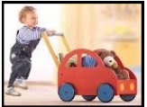  The child is pushing the car to speed it up.
A force that slows something down | 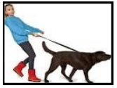  The girl is pulling the dog to slow it down.
A force that changes the shape of something | 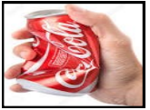  The can is being squeezed so that it changes shape and becomes smaller.
A force that changes the direction of something |   When the ball is hit with the racket, it will change direction.
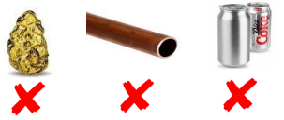
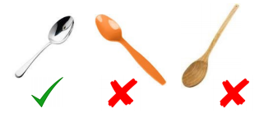
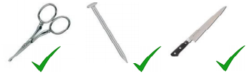
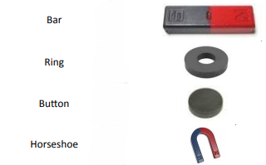
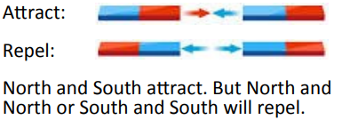
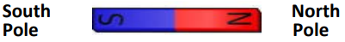
Magnetic Forces
Why is magnetism different? | All of the forces above needed contact between two objects for them to happen.  Magnetic forces can act at a distance.
Magnets have a North Pole and a South Pole
Magnets attract or repel each other
Magnets only attract certain types of metals, other materials such as glass, plastic and wood aren't attracted.

Metals such as iron, nickel and cobalt are attracted to magnets.

Most metals however are not attracted to magnets, these include copper, silver, gold, magnesium, platinum, aluminium and more.
Key Vocabulary
attract | if one object attracts another, it causes the second object to move towards
friction | the resistance of motion when there is contact between two surfaces
force | the pulling or pushing effect that something has on something else
gravity | the force which causes things to drop to the ground
magnet | a piece of iron or other material which attracts magnetic materials towards it
magnetic field | an area around a magnet, or something functioning as a magnet, in which the magnet’s power to attract things is felt
motion | moving from one place to another
nonmagnetic | not magnetic
opposite | used to describe things of the same kind which are completely different in a particular way
pull | using force to move something towards you
push | using force to move something away from you
repel | when a magnetic pole repels another magnetic pole, it gives out a force that pushes the other pole away
resistance | a force which slows down a moving object or vehicle
Types of Magnets

