Science
Topic: Light Yr grp: 3
Key Vocabulary
angle | the direction from which you look at something
bright | a colour that is strong and noticeable, and not dark
chemical reactions | a process that involves changes in the structure of something
dark | the absence of light
dim | light that is not bright
electricity | a form of energy that can be carried by wires and is used for heating and lighting, and to provide power for machines
emits | to emit a sound or light means to produce it
light | a brightness that lets you see things
mirror | a flat piece of glass which reflects light, so that when you look at it you can see yourself reflected in it
opaque | something you cannot see through
product | something that is produced
reflection | when light bounces off a surface
shadows | a dark shape on a surface that is made when something stands between a light and the surface
torches | a small electric light which is powered by batteries and which you can carry
translucent | some light can pass through it
transparent | completely see through
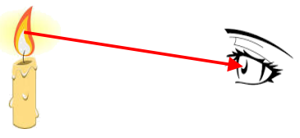
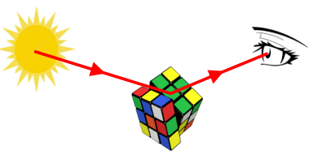
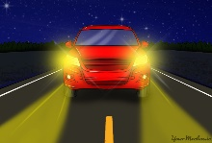
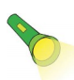
Why do we need light? | We need light so that we are able to see in the dark.  This is because the dark is the absence of light. The Sun and stars always give us light but we can only see the stars when it is dark.  At night time, we cannot see the Sun’s light as the Earth turns and our part of the Earth is not lit up by the Sun at night.  When we are driving, we need car headlights or street lights to help us.  If we are walking or out in the dark, we would need torches to help us see. You should not look directly into the torch as this is dangerous.

A diagram to show how light sources allow us to see
We see things when light from a source enters our eyes.

Here the light goes form the light source, bounces off the object and into your eyes, so that you see the object.
Light travels directly from the light source (candle flame) to the eye.
WARNING: IT IS NOT SAFE TO EVER LOOK DIRECTLY AT THE SUN, EVEN WHEN WEARING SUN GLASSES.
Light Sources
We need light in order to see things. When there is no light, we say it is dark.
What is a light source? | A light source is something that makes its own light.
Common sources of light | • The Sun  • The stars  • Flames  • Electric lights  • Some animals (fireflies and glow worms make their own light)
Things you may think are light sources but aren’t. | • The Moon  • A mirror  • Shiny objects  These basically reflect light from a light source but aren’t light sources themselves.
Reflection | • Light bounces off some materials better than others.  • Shiny objects reflect light well.
Shadows
How is a shadow formed? | 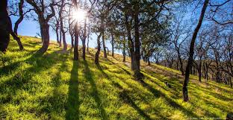  When light from a source is blocked by an opaque object, you get a shadow.
How does the size of the shadow change? | • If an object is moved closer to the light sources, the shadow gets bigger.  • If an object is moved further away from the light source, the shadow gets smaller.


