Key Vocabulary
aorta | the main artery through which blood leaves your heart before it flows through the rest of your body
arteries | a tube in your body that carries oxygenated blood from your heart to the rest of your body
blood vessels | the narrow tubes through which your blood flows. Arteries, veins and capillaries are blood vessels.
capillaries | tiny blood vessels in your body
carbon dioxide | a gas produced by animals and people breathing out
circulatory system | the system responsible for circulating blood through the body, that supplies nutrients and oxygen to the body and removes waste products such as carbon dioxide
deoxygenated blood | blood that does not contain oxygen
heart | the organ in your chest that pumps the blood around your body
lungs | two organs inside your chest which fill with air when you breathe in. They oxygenate the blood and remove carbon dioxide from it.
nutrients | substances that help plants and animals to grow
organ | a part of your body that has a particular purpose
oxygen | a colourless gas that plants and animals need to survive
oxygenated blood | blood that contains oxygen
pulse | the regular beating of blood through your body. How fast or slow your pulse is depends on the activity you are doing.
respiration | process of respiring; breathing; inhaling and exhaling air
vein | a tube in your body that carries deoxygenated blood to your heart from the rest of your body
vena cava | a large vein through which deoxygenated blood reaches your heart from the body
Science
Topic: Animals inc. Humans Yr grp: 6
Key:
Oxygenated Blood
Deoxygenated Blood
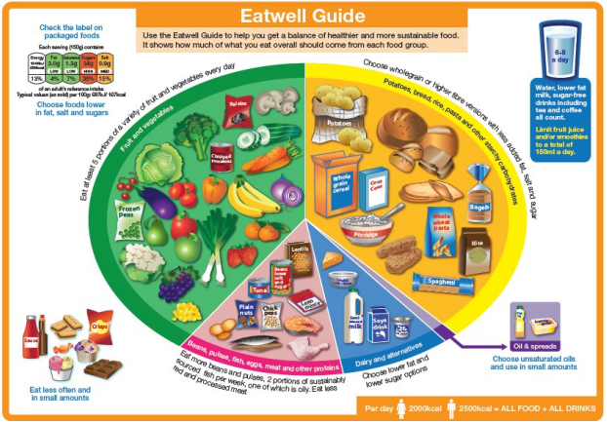
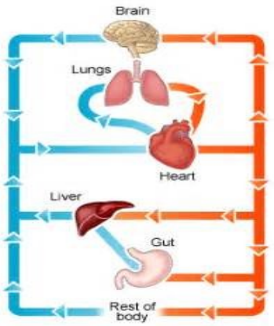
Healthy Lifestyle
Things humans need to be healthy | • To have a balanced diet of the right amount of different types of food and drink  • To exercise regularly  • To be hygienic
What is a balanced diet? | • See the Eatwell guide: (http://www.nhs.uk/Livewell/Goodfood/ Documents/The-Eatwell-Guide-2016.pdf)  • Drink 6-8 cups/glasses of fluids each day
Health risks that can damage the body | • Smoking  • Drugs  • Alcohol  • Obesity
Dangers of smoking | • Addictive  • Can cause heart disease and cancer
Dangers of drugs | • Addictive  • Can damage the brain or cause death
Dangers of alcohol | • Ok in small amounts for adults  • Can damage the liver, heart and stomach
Dangers of obesity | • Can cause heart disease  • Can lead to cancer

The Human Circulatory System
The main parts of the human circulatory system | • Heart  • Blood vessels  • Blood
What does the heart do? | • The heart pumps the blood through the blood vessels so that food and oxygen can get to all the parts of the body
What do the blood vessels do? | • The blood vessels carry the blood around the body
There are three main types of blood vessels: | • The arteries, which carry the oxygenated blood away from the heart  • The capillaries, which enable the actual exchange of energy between the blood and the tissues  • The veins, which carry deoxygenated blood from the capillaries back toward the heart
What does the blood do? | • Blood moves nutrients and oxygen around the body

