What is Evolution?
What is evolution? | Evolution is the way that living things change over time.
Do things evolve? | • We know that living things used to look a lot different to how they do now. We know this because fossils have been found that show creatures that look a lot different to how they do today.  • Fossils show us that living things have changed over time.
So how do things evolve? | • A famous scientist, Charles Darwin observed that although individuals in a species shared similarities, they were not exact copies of each other.  • He noticed that there were small differences or variations between them.  • He also noticed that everything in the natural world was in competition.  • The winners were those that had characteristics which made them better adapted for survival. For example, they were stronger, faster, cleverer or more attractive than others in their species.  • These living things were more likely to reproduce and pass on their useful characteristics to their offspring.  • Individuals that were poorly adapted were less likely to survive and their characteristics were not as likely to be inherited.  • Over time, the characteristics that help survival become more common and a species gradually changes.  • Given enough time, these small changes can add up to the extent that a new species altogether can evolve.
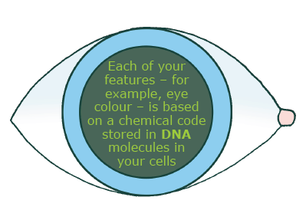
Variation
What’s the important thing to know? | • Living things produce offspring of the same kind.  For example, owls produce baby owls and humans produce baby humans… BUT… Normally offspring vary and are not identical to their parents.
So what? | • Natural variation like this can lead to offspring being more likely or less likely to survive in their environment.  • If the variant makes them more likely to survive, they are more likely to be alive to pass this variant to their offspring.  • As a result, this variant is more likely to become more common in this species.
Adaptation
What is adaptation? | • Adaption is when things evolve to overcome challenges in their environment. For example by adapting their behaviour.
Examples of adaptation | Migration  • Birds have adapted to move around the world to find weather and food sources to suit them.  • Birds that didn’t do this may have run out of food and died.
Examples of adaptation | Sticking together in packs  • Animals that learned to live in packs were more likely to be safer and more successful when hunting, leading them to be more likely to survive.

Science
Topic: Evolution and Inheritance Yr grp: 6
Key Vocabulary
ancestor | an early type of animal or plant from which a later, usually dissimilar, type has evolved
biodiversity | a wide variety of plant and animal species living in their natural environment
biome | a large naturally occurring community of animals and plants occupying a major habitat
breeding | the process of producing plants or animals by reproduction
characteristics | the qualities or features that belong to them and make them recognisable
environment | all the circumstances, people, things, and events around them that influence their life
extinct | no longer has any living members, either in the world or in a particular place
fossil | the hard remains of a prehistoric animal or plant that are found inside a rock
generation | the act or process of bringing into being; through reproduction, especially of offspring
inherit | if you inherit a characteristic you are born with it, because your parents or ancestors also had it.
maladaptation | the failure to adapt properly to a new situation or environment
mutation | characteristics that are not inherited from the parents or ancestors and appear as new characteristics
natural selection | a process by which species of animals and plants that are best adapted to their environment survive and reproduce, while those that are less well adapted die out
offspring | a person's children or an animal's young
palaeontology | the study of fossils as a guide to the history of life on Earth
reproduction | when an animal or plant produces one or more individuals similar to itself
species | a class of plants or animals whose members have the same main characteristics and are able to breed with each other
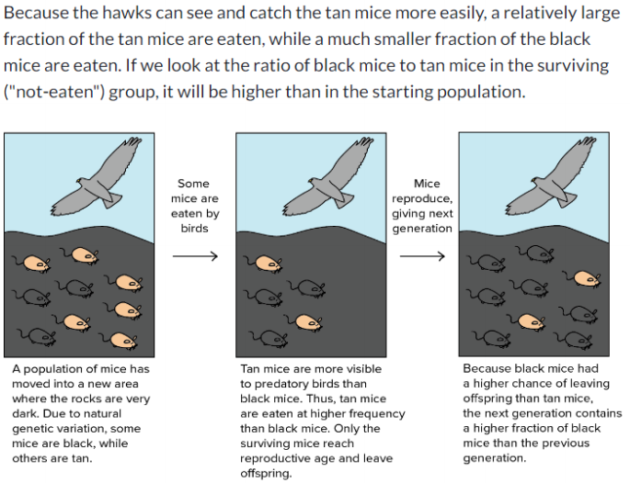
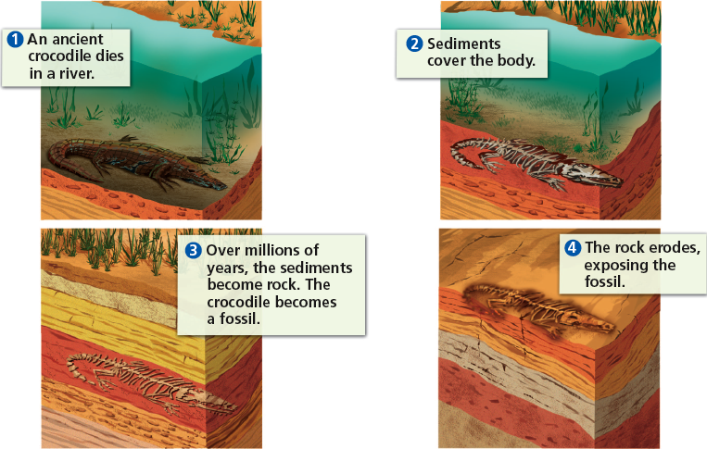
Fossil Formation How can variation impact on evolution?

Natural Selection
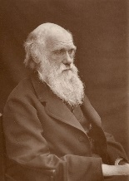
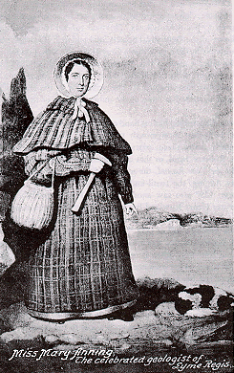
Charles Darwin

• Boarded a ship named
‘HMS Beagle’ in 1831, for a 5 year
voyage around the world to collect rock, plant and animal samples.
• On this journey, he noticed how the same species had adapted amongst different habitats and in 1858, he revealed his ‘theory of evolution by natural selection’ to explain this.
• In 1859, he explained how species evolved through ‘Natural Selection’ in On the Origin of Species. This was shocking because up until this point, it was believed that all living things were made by one creator (God).

Mary Anning

• Born in Dorset, England (1799)
• Started collecting fossils with her father to increase their income – they were known as ‘curiosities’ back then.
• When she was 12, she found a 5.2m skeleton. She thought this was a crocodile but it was later deemed a ‘fish lizard’.
• In 1823, she uncovered the first plesiosaur skeleton (a long-necked sea creature) and later the pterodactyl and fossilised poo!
• Anning wasn’t taken seriously when she was alive because of her gender and background.



