Science
Topic: Light Yr grp: 6
Shadows
How is a shadow formed? | • When light from a source is blocked by an opaque object, you get a shadow.  •These shadows have the same shape as the objects that cast them. Shadows can be different sizes depending on where the light source is.
Scientists call light-bending refraction. Different materials refract (bend) light by different amounts. You can also refract light with a transparent prism.

How does the size of the shadow change? | • If an object is moved closer to the light sources, the shadow gets bigger.  • If an object is moved further away from the light source, the shadow gets smaller.

How do we see?
We see things when: | • Light travels from a light source to our eyes.  • Light from a light source, to an object, then to our eyes.

Key Vocabulary
dark | the absence of light
dim | light that is not bright
emits | to emit a sound or light means to produce it
light | a brightness that lets you see things
mirror | a flat piece of glass which reflects light, so that when you look at it you can see yourself reflected in it
opaque | if an object or substance is opaque, you cannot see through it
reflects | sent back from the surface and not pass through it
refraction | When light travels from air into water, it slows down, causing it to change direction slightly. This change of direction is called refraction.
shadows | a dark shape on a surface that is made when something opaque stands between a light and the surface
source | where something comes from
surface | the flat top part of something or the outside of it
translucent | some light can pass through it
transparent | you can see through it

#

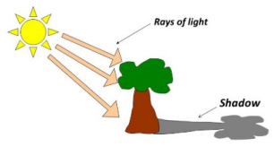
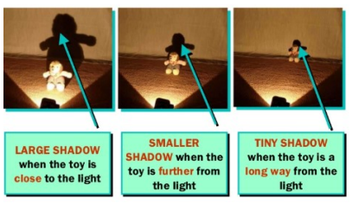
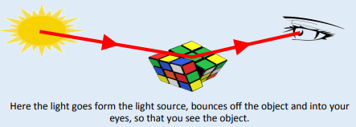
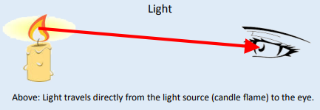
WARNING: IT IS NOT SAFE TO EVER LOOK DIRECTLY AT THE SUN, EVEN WHEN WEARING SUNGLASSES.
Light Sources
We need light in order to see things. When there is no light we say it is dark.
What is a light source? | • A light source is something that makes its own light.
Key Facts About Light
Things you need to know about light | • Light travels in straight lines. When you place a torch on a table in a dark room, the beam travels in a straight line.
Things you need to know about light | • Light travels very, very fast - 186,282 miles per second. (that’s like travelling around the world over 7 times in a second)
Things you need to know about light | • If something gets in the way of light, a shadow is formed.

